 | Faculty of Computing and AI, Air University, Islamabad  Department of Creative Technologies  Software Engineering | 

PakSentiment

By

Muhammad Asim 221794
Muhammad Ahmed 221784
Muhammad Usman 221772

Supervisor
Dr. Imran Ihsan

Bachelor of Science in Software Engineering (2022-2026)

The candidate confirms that the work submitted is their own and appropriate
credit has been given where reference has been made to the work of others.

 | Faculty of Computing and AI, Air University, Islamabad  Department of Creative Technologies  Software Engineering | 

PakSentiment

A project presented to
AIR University, Islamabad

In partial fulfillment
of the requirement for the degree of

Bachelors of Science in Software Engineering (2022-2026)

By

Muhammad Asim 221794
Muhammad Ahmed 221784
Muhammad Usman 221772

DECLARATION

We hereby declare that this software, neither whole nor as a part has been copied out from any source. It is further declared that we have developed this software and accompanied report entirely on the basis of our personal efforts. If any part of this project is proved to be copied out from any source or found to be reproduction of some other, we will stand by the consequences. No Portion of the work presented has been submitted of any application for any other degree or qualification of this or any other university or institute of learning.

Muhammad Asim Muhammad Ahmed

--------------------------- ---------------------------

Muhammad Usman

---------------------------

CERTIFICATE OF APPROVAL
It is to certify that the final year project of BS (SE) “PakSentiment” was developed by
Muhammad Asim (221794), Muhammad Ahmed (221784) and Muhammad Usman (221772) under the supervision of “Prof. Dr. Imran Ihsan” and that in (their/his/her) opinion; it is fully adequate, in scope and quality for the degree of Bachelors of Science in Software Engineering.

---------------------------------------
Dr. Imran Ihsan (Supervisor)

---------------------------------------
External Examiner

---------------------------------------
Head of Department
(Department of Creative Technologies)

Executive Summary
PakSentiment is an AI-powered multilingual sentiment analysis platform developed to analyze public opinion from Pakistani social media and digital platforms. The system focuses on collecting, processing, translating, and analyzing textual data from sources such as Twitter, Reddit, online forums, and web platforms. The main objective of the project is to help policymakers, researchers, NGOs, analysts, and businesses understand public sentiment related to social, political, and economic issues in Pakistan.
Traditional methods of public opinion analysis, such as surveys and manual monitoring, are often time-consuming, costly, and limited in scale. Existing international sentiment analysis platforms mainly focus on English language content and provide limited support for regional Pakistani languages such as Urdu, Punjabi, Pashto, and Roman Urdu. PakSentiment addresses this gap by providing localized multilingual sentiment analysis specifically designed for the Pakistani environment.
The system uses modern Artificial Intelligence (AI), Natural Language Processing (NLP), and Machine Learning (ML) techniques to classify social media posts into positive, negative, and neutral sentiments. The project includes several modules such as data collection, data filtration, translation, sentiment analysis, model evaluation, visualization, and service management. Data is collected automatically through APIs and web scraping tools, then cleaned and preprocessed before analysis. Translation models are used to standardize multilingual content into a consistent format for accurate sentiment classification.
PakSentiment follows a modular and scalable architecture using technologies such as Next.js, NestJS, FastAPI, Go, MongoDB, PostgreSQL, Redis, Docker, and LLaMA-based AI models. The system provides interactive dashboards and visualization tools that display sentiment trends, public reactions, and analytical summaries in real time. Users can also generate reports in formats such as PDF and CSV for research and decision-making purposes.
The project contributes significantly to the fields of Software Engineering, Artificial Intelligence, Data Mining, and Web Development by integrating concepts learned during the BS Software Engineering program. PakSentiment aims to transform large volumes of unstructured social media data into meaningful insights that can support governance, research, public policy evaluation, business intelligence, and social trend monitoring in Pakistan.
Acknowledgement
All praise is to Almighty Allah who bestowed upon us a minute portion of His boundless knowledge by virtue of which we were able to accomplish this challenging task.

We are greatly indebted to our project supervisor “Prof. Dr. Imran Ihsan”. Without their personal supervision, advice and valuable guidance, completion of this project would have been doubtful. We are grateful to them for their encouragement and continual help during this work.

And we are also thankful to our parents and family who have been a constant source of encouragement for us and brought us with the values of honesty & hard work.

Muhammad Asim Muhammad Ahmed

--------------------------- ---------------------------

Muhammad Usman

---------------------------

Abbreviations
AI | Artificial Intelligence
NLP | Natural Language Processing
ML | Machine Learning
API | Application Programming Interface
UI | User Interface
UX | User Experience
CSV | Comma Separated Values
PDF | Portable Document Format
SRS | Software Requirements Specification
SDD | Software Design Document
SDS | Software Design Specification
OOP | Object-Oriented Programming
SQL | Structured Query Language
DBMS | Database Management System
JSON | JavaScript Object Notation
REST | Representational State Transfer
HTTP | HyperText Transfer Protocol
HTTPS | HyperText Transfer Protocol Secure
TLS | Transport Layer Security
AES | Advanced Encryption Standard
RBAC | Role-Based Access Control
OAuth | Open Authorization
UUID | Universally Unique Identifier
CRUD | Create, Read, Update, Delete
IDE | Integrated Development Environment
SSR | Server Side Rendering
SSG | Static Site Generation
LLM | Large Language Model
BLEU | Bilingual Evaluation Understudy
TER | Translation Edit Rate
MTBF | Mean Time Between Failures
RTO | Recovery Time Objective
WCAG | Web Content Accessibility Guidelines
PII | Personally Identifiable Information
AWS | Amazon Web Services
KPI | Key Performance Indicator
CSV | Comma Separated Values
JWT | JSON Web Token
ORM | Object Relational Mapping
SDK | Software Development Kit
SEO | Search Engine Optimization
URL | Uniform Resource Locator
URI | Uniform Resource Identifier
GPU | Graphics Processing Unit
CPU | Central Processing Unit
ETL | Extract, Transform, Load
CDN | Content Delivery Network
CRUD | Create, Read, Update, Delete
F1-Score | Harmonic Mean of Precision and Recall
CI/CD | Continuous Integration / Continuous Deployment
NMT | Neural Machine Translation
LTS | Long Term Support
NoSQL | Non-Relational Database System
UTF | Unicode Transformation Format
ISO | International Organization for Standardization

Table of Contents
1 Introduction 12
1.1 Vision Statement 12
1.2 Related System Analysis/Literature Review 12
1.2.1 Brandwatch 12
1.2.2 Hootsuite Insights 12
1.2.3 Google Cloud Natural Language API 12
1.2.4 IBM Watson Natural Language Understanding 12
1.3 Project Deliverables 13
1.4 System Limitations/Constraints 13
1.5 Tools and Technologies 14
1.6 Relevance to Course Modules 14
2 Problem Definition 16
2.1 Problem Statement 16
2.2 Problem Solution 16
2.3 Objectives of the Proposed System 17
2.4 Scope 17
2.5 Modules 17
2.5.1 Module 1: Data Collection 17
2.5.2 Module 2: Data Filtration 18
2.5.3 Module 3: Translation 18
2.5.4 Module 4: Sentiment Analysis 18
2.5.5 Module 5: Model Evaluation 18
2.5.6 Module 6: Model Improvement 18
2.5.7 Module 7: Visualization 18
2.5.8 Module 8: Service Manager 18
3 Requirement Analysis 19
3.1 User classes and characteristics 19
3.2 Requirement Identifying Technique 20
3.2.1 Use Cases: 21
3.3 Functional Requirements 36
3.3.1 Module 1: Data Collection 36
3.3.2 Module 2: Data Filtration 37
3.3.3 Module 3: Translation 39
3.3.4 Module 4: Sentiment Analysis 40
3.3.5 Module 5: Model Evaluation 41
3.3.6 Module 6: Model Improvement 42
3.3.7 Module 7: Visualization 43
3.3.8 Module 8: Service Manager 45
3.4 Non-Functional Requirements 46
3.4.1 Reliability 46
3.4.2 Usability 46
3.4.3 Performance 46
3.4.4 Security 47
3.4.5 Maintainability 47
3.4.6 Scalability 47
3.4.7 Compliance 47
3.4.8 Data Integrity 48
3.4.9 Privacy 48
3.4.10 Interoperability 48
3.4.11 Resilience 48
3.4.12 Accessibility 48
3.4.13 Cost-Effectiveness 48
3.4.14 Adaptability 49
3.4.15 Portability 49
3.4.16 User Satisfaction 49
3.5 External Interface Requirements 49
3.5.1 User Interfaces Requirements 49
3.5.2 Software interfaces 49
3.5.3 Hardware interfaces 50
3.5.4 Communications interfaces 50
4 Design and Architecture 51
4.1 Architectural Design 51
4.2 Design Models 53
4.2.1 Process Model 53
4.2.2 Activity Diagrams 54
4.2.3 Class Diagram: 61
4.2.4 DataFlow Diagrams upto level 2 62
4.2.5 System Sequence Diagrams: 64
4.2.6 State Transition Diagrams: 71
4.3 Data Design 77
4.3.1 PostgreSQL Schema (Relational Data & Identity) 77
4.3.2 MongoDB Schema (NoSQL Document & Log Stores) 79
4.3.3 Redis Schema (Cache Maps & Queues) 82
4.3.4 Data Dictionary 83
4.4 Human Interface Design 84
4.4.1 Screen Images 84
4.4.2 Screen Objects and Actions 88
5 Implementation 91
5.1 Algorithm 91
5.2 External APIs/SDKs 95
5.3 User Interface 96
5.4 Deployment 107
5.4.1 Hosting and Infrastructure 107
5.4.2 Application Subsystems 107
5.4.3 Port Mapping Summary 110
5.4.4 Deployment Procedure 110
5.4.5 Build Strategy 110
6 Testing and Evaluation 111
6.1 Unit Testing 111
6.1.1 Objective 111
6.1.2 Scope 111
6.1.3 Approach 111
6.1.4 Representative Unit Test Cases 111
6.2 Functional Testing 112
6.2.1 Objective 112
6.2.2 Scope 112
6.2.3 Test Design 112
6.2.4 Representative Functional Test Cases (table format) 112
6.3 Business Rules Testing 114
6.3.1 Objective 114
6.3.2 Scope 114
6.3.3 Method 114
6.3.4 Example Decision Table & Test Cases 114
6.4 Integration Testing 115
6.4.1 Objective 115
6.4.2 Scope 115
6.4.3 Integration Scenarios & Tests 115
6.4.4 Integration Test Data 115
6.5 Test Execution Plan 115
6.5.1 Environments 115
6.5.2 Schedule 116
6.5.3 Entry Criteria 116
6.5.4 Exit Criteria 116
6.6 Testing Tools and Artifacts 116
6.6.1 Tools 116
6.6.2 Artifacts 116
6.7 Reporting and Acceptance 116
6.8 Traceability 117
7 Conclusion and Future Work 118
7.1 Conclusion 118
7.2 Future Work 118
8. References 119

List of Figures

Figure 1 Use Case Diagram 01 24
Figure 2 Use Case diagram 2 26
Figure 3 Use Case diagram 3 29
Figure 4 Use Case diagram 4 31
Figure 5 Use Case diagram 5 33
Figure 6 Use Case diagram 6 35
Figure 7 Use Case diagram 7 37
Figure 8 Architecture Diagram 54
Figure 9 Activity diagram 01 56
Figure 10 Activity diagram 02 57
Figure 11 Activity diagram 03 58
Figure 12 Activity diagram 04 59
Figure 13 Activity diagram 05 60
Figure 14 Activity diagram 06 61
Figure 15 Activity diagram 07 62
Figure 16 Class Diagram 63
Figure 17 Entity Relation Diagram 64
Figure 18 DFD level 0 65
Figure 19 DFD level 01 65
Figure 20 DFD level 02 66
Figure 21 System Sequence 01 67
Figure 22 System Sequence 02 68
Figure 23 System Sequence 03 69
Figure 24 System Sequence 04 70
Figure 25 System Sequence 05 71
Figure 26 System Sequence 06 72
Figure 27 System Sequence 07 73
Figure 28 State Transition 01 74
Figure 29 State Transition 02 75
Figure 30 State Transition 04 76
Figure 31 State Transition 05 77
Figure 32 State Transition 06 78
Figure 33 State Transition 07 79
Figure 34 Home Page HID 87
Figure 35 Main Dashboard HID 88
Figure 36 Analysis and chart HID 88
Figure 37 Result Screen HID 89
Figure 38 Translation Screen HID 89
Figure 39 Pricing Screen HID 90
Figure 40 About Screen HID 90

Introduction
This chapter provides an overview of the PakSentiment project. It introduces the vision of the system, analyzes existing related systems, and identifies the project deliverables and limitations. The purpose of this chapter is to present the motivation behind the development of the system and outline its intended capabilities and constraints.

Vision Statement
For policymakers, researchers, NGOs, and analysts in Pakistan who need reliable insights into public opinion across multiple languages and online platform. The PakSentiment System Is an AI-powered multilingual sentiment analysis platform that collects public data from social media and digital sources, analyzes sentiment using advanced NLP and machine learning models, and provides interactive dashboards and reports for better decision-making. Unlike traditional survey methods and manual monitoring processes that are slow, fragmented, and limited in scale. Our product provides real-time multilingual sentiment intelligence, automated analysis, and visual insights that help stakeholders understand public opinion efficiently and respond quickly to emerging social trends.

Related System Analysis/Literature Review

Brandwatch
Brandwatch is a social media monitoring and analytics platform that analyzes public opinion and brand sentiment across various online platforms. It uses artificial intelligence to detect trends and insights from large volumes of online data. However, it primarily focuses on global markets and English language analysis. Its limited support for regional languages makes it less effective for analyzing multilingual discourse in Pakistan.

Hootsuite Insights
Hootsuite Insights is a social media analytics tool that tracks online conversations and sentiment across different platforms. It helps organizations understand public perception and monitor brand reputation in real time. However, the platform is mainly designed for marketing and brand monitoring rather than governance or public policy analysis. It also lacks specialized support for South Asian languages.

Google Cloud Natural Language API
Google Cloud Natural Language API provides powerful sentiment analysis and entity recognition features through machine learning models. It is widely used for analyzing textual data and extracting insights. However, the system is not specifically designed for large-scale public sentiment monitoring in a multilingual context. Additionally, reliance on external cloud APIs can create cost and privacy concerns.

IBM Watson Natural Language Understanding
IBM Watson NLU provides advanced text analysis capabilities including sentiment detection, emotion analysis, and entity extraction. It is used by businesses for customer feedback analysis and content understanding. Despite its powerful capabilities, the platform requires extensive configuration and subscription costs, making it less accessible for academic or research projects.

Table 1 Related System Analysis with proposed project solution
Application Name | Weakness | Proposed Project Solution
Brandwatch | Limited support for Pakistani regional languages and focuses on marketing analytics. | PakSentiment supports Urdu, Pashto, Punjabi, and English for better regional analysis.
Hootsuite Insights | Designed mainly for brand monitoring rather than governance or research insights. | PakSentiment focuses on public sentiment analysis related to social issues and governance.
Google Cloud Natural Language API | Requires cloud dependency and subscription costs. | PakSentiment uses locally hosted AI models to reduce cost and increase data control.
IBM Watson NLU | Complex setup and expensive enterprise-level solution. | PakSentiment provides a lightweight and customizable academic solution tailored for Pakistan.

Project Deliverables
The main deliverables of the PakSentiment project include:
- A multilingual sentiment analysis system capable of analyzing public opinion from multiple online sources.
- A data ingestion and preprocessing pipeline for collecting social media data.
- An AI-based sentiment analysis module for classifying text into positive, negative, and neutral sentiments.
- A translation module for converting regional languages into English for consistent analysis.
- A web-based dashboard for visualizing sentiment trends and insights.
- Automated reporting tools that allow users to export data in formats such as CSV and PDF.
- Documentation, including Software Requirements Specification (SRS), Software Design Document (SDD), and user manuals.

System Limitations/Constraints

LI-1: The system relies on publicly available data from social media platforms, and access may be limited due to API restrictions or rate limits imposed by these platforms.
LI-2: Sentiment analysis accuracy may vary depending on the complexity of language, slang, sarcasm, or mixed-language content used in social media posts.
LI-3: The system requires stable internet connectivity to collect real-time data from online platforms.
LI-4: Processing large volumes of multilingual data may require significant computational time and resources, especially when using large language models.
LI-5: The system focuses primarily on sentiment analysis and may not fully capture deeper contextual meanings such as political nuance or cultural interpretation.

Tools and Technologies
Mention all the hardware/software tools and technologies with version number.

Table 2 Tools and Technologies for Proposed Project
Tools  And  Technologies | Tools | Version | Rationale
 | VS Code | 2024+ | Primary IDE for TypeScript, Python, and Go development.
 | Docker Desktop | 4.x | Containerization for Nitter proxies and local database services.
 | PostgreSQL | 16.x | Relational DBMS for users, authentication, and structured metadata.
 | MongoDB | 7.x | NoSQL Document store for high-volume scraped data and analytics.
 | Redis | 6.2 | Fast in-memory caching for scraping results and Nitter sessions.
 | Postman | Latest | API testing for NestJS, FastAPI, and Go sidecar endpoints.
 | Technologies | Version | Rationale
 | Next.js | 15.5 | Frontend Framework for SSR/SSG and high-performance React rendering.
 | NestJS | 11.0 | Backend Orchestrator providing modular and scalable architecture.
 | FastAPI | 0.119 | High-performance Python gateway for social media scraping and AI services.
 | Go (Golang) | 1.25 | Concurrent scraping engine (Colly) for high-speed HTML extraction.
 | TypeScript | 5.7 | Type-safe development across Frontend and Main Server.
 | Python | 3.12 | Used for Data Science, NLP, and Scrapling integration in the Gateway.
 | React JS | 19.x | UI library for building the PakSentiment dashboard and visualizations.
 | Tailwind CSS | 3.4+ | Utility-first CSS framework for rapid and responsive UI design.
 | MUI (Material UI) | 7.3 | Component library for professional enterprise-grade UI elements.
 | LLaMA 3.1 (Groq) | 8B/70B | Primary AI model for high-throughput sentiment classification.
 | Ollama (Phi-3) | Mini | Local-first LLM inference for cost-effective sentiment analysis.

Relevance to Course Modules
The PakSentiment project integrates knowledge and skills acquired from multiple courses studied during the Bachelor of Science in Software Engineering (BSSE) program. The project mainly focuses on sentiment analysis of Pakistani social media data and therefore applies concepts from software development, data processing, and artificial intelligence.

- Programming Fundamentals / Object-Oriented Programming: These courses provide the core programming skills required to implement the system modules such as data collection, preprocessing, and sentiment analysis.
- Data Structures and Algorithms: Efficient data handling, filtering, and processing of large social media datasets rely on concepts learned in these courses.
- Database Systems: The project requires structured storage and management of collected data, analysis results, and user information using database design principles.
- Software Engineering: Concepts such as requirement analysis, system design, documentation (SRS, SDS), and software development lifecycle are applied throughout the project.
- Artificial Intelligence / Machine Learning / Data Mining: These courses are directly related to the sentiment analysis model used to classify opinions from social media text.
- Web Development / Human Computer Interaction: These courses contribute to designing the user interface and dashboard used for visualization of sentiment trends and analytical results.
- Software Testing and Quality Assurance: Testing techniques ensure the reliability, performance, and correctness of the developed system.

Thus, the PakSentiment project serves as a practical implementation of theoretical and technical knowledge gained from different (BSSE) course modules, combining software engineering practices with modern AI-based sentiment analysis techniques.

Problem Definition
This chapter describes the main problem that the developed system aims to solve. It explains the current issues in analyzing public opinion from Pakistani social media platforms and highlights how the proposed system will address these problems. The chapter also presents the solution, objectives, scope, and modules of the proposed system.

Problem Statement
In recent years, social media platforms such as Twitter, Facebook, and online forums have become major sources of public opinion in Pakistan. Millions of users express their views about politics, social issues, government policies, brands, and public events through online posts and comments. However, analyzing this massive amount of data manually is extremely difficult and time-consuming. Organizations, researchers, and policymakers often struggle to understand the public sentiment related to different national issues. Currently, there is no centralized system specifically designed to analyze Pakistani social media sentiments in a structured and automated way. Most available tools are either global solutions or do not properly support local languages such as Urdu and Roman Urdu. As a result, a large portion of Pakistani online opinion remains unstructured and underutilized. Businesses and government institutions cannot effectively measure public reactions to their decisions or products. Researchers also face challenges in collecting, filtering, and analyzing large datasets from social media platforms. Furthermore, the lack of proper visualization tools makes it difficult to interpret sentiment trends over time. Without automated analysis, identifying positive, negative, or neutral opinions becomes inefficient. This problem highlights the need for a specialized sentiment analysis system tailored to Pakistani social media content. Therefore, the development of the PakSentiment system aims to collect, process, analyze, and visualize public sentiment from Pakistani social media data in an efficient and automated manner.

Problem Solution
The proposed system, (PakSentiment) is designed to automatically collect and analyze public opinions from social media platforms related to Pakistani topics and issues. The system will gather textual data from online sources using automated data collection techniques. After collecting the data, the system will filter irrelevant or noisy information to ensure accurate analysis. Since many social media posts are written in Urdu or Roman Urdu, the system will include translation and preprocessing mechanisms to standardize the text. Machine learning and natural language processing techniques will then be applied to classify the sentiment of each post as positive, negative, or neutral. The system will also evaluate the performance of the sentiment analysis model to ensure reliability and accuracy. Model improvement techniques will be applied to enhance prediction performance over time. The analyzed data will be presented through visual dashboards that allow users to easily understand public sentiment trends. These visualizations will include graphs, charts, and summaries of public opinion. The system will help researchers, organizations, and policymakers understand public perception regarding different issues. Businesses will be able to analyze customer opinions about products or services. Government institutions can evaluate public responses to policies or announcements. The system will reduce manual effort in data analysis and increase the efficiency of sentiment monitoring. Overall, PakSentiment will provide a centralized platform for analyzing Pakistani social media sentiment using automated and intelligent techniques.

Objectives of the Proposed System
BO-1: Develop an automated system to collect social media data related to Pakistani public opinion.
BO-2: Classify social media posts into positive, negative, and neutral sentiments using machine learning techniques.
BO-3: Improve the accuracy of sentiment analysis models through evaluation and model improvement techniques.
BO-4: Provide graphical visualizations and dashboards to display sentiment trends.
BO-5: Reduce manual effort required to analyze large amounts of social media data.
BO-6: Provide insights that help researchers, organizations, and policymakers understand public opinion.

Scope
The PakSentiment system focuses on analyzing sentiments from Pakistani social media data to understand public opinion trends. The system will collect textual data from social media platforms and store it in a structured database. After data collection, the system will perform filtration to remove irrelevant or duplicate data. The filtered data will then undergo preprocessing and translation processes to handle multiple languages including Urdu and Roman Urdu. The system will apply machine learning algorithms to classify sentiments of social media posts into positive, negative, or neutral categories. Model evaluation techniques will be used to measure the performance of the sentiment classification models. If necessary, the system will apply model improvement methods to enhance prediction accuracy. The processed data and sentiment results will be presented through an interactive visualization dashboard. Users will be able to view sentiment statistics, trends, and graphical summaries. The system will mainly be used for research, analytical, and monitoring purposes. It will allow users to observe how public opinion changes over time regarding specific topics or events. The project focuses on sentiment analysis of textual data rather than multimedia content such as images or videos. The system will operate as a web-based platform accessible to authorized users. PakSentiment will help transform large amounts of unstructured social media data into meaningful insights for decision-making.

Modules
The PakSentiment system consists of several modules responsible for performing different tasks in the sentiment analysis pipeline.

Module 1: Data Collection
FE-1: Collect textual data from social media platforms.
FE-2: Store collected data in the system database.
FE-3: Schedule automated data collection tasks.

Module 2: Data Filtration
FE-1: Remove duplicate posts and irrelevant data.
FE-2: Filter spam or non-informative content.
FE-3: Prepare clean data for further processing.

Module 3: Translation
FE-1: Translate Urdu or Roman Urdu text into standardized language format.
FE-2: Normalize textual content for analysis.
FE-3: Prepare translated text for sentiment analysis.

Module 4: Sentiment Analysis
FE-1: Apply machine learning models for sentiment classification.
FE-2: Categorize text into positive, negative, or neutral sentiments.
FE-3: Store analysis results in the database.

Module 5: Model Evaluation
FE-1: Measure model accuracy and performance.
FE-2: Generate evaluation metrics such as precision, recall, and F1-score.

Module 6: Model Improvement
FE-1: Improve model performance through retraining techniques.
FE-2: Optimize parameters for better sentiment classification results.

Module 7: Visualization
FE-1: Display sentiment trends using charts and graphs.
FE-2: Provide dashboards for analyzing sentiment distribution.
FE-3: Allow users to view summarized analytical reports.

Module 8: Service Manager
FE-1: Manage system services and processes.
FE-2: Monitor system performance and task execution.
FE-3: Control data processing workflows.

Requirement Analysis
This chapter describes the requirements of the proposed PakSentiment system. It identifies the different types of users who will interact with the system and explains the techniques used to gather system requirements. The chapter also presents the functional and non-functional requirements that define how the system should operate and the quality standards it must satisfy. Additionally, it describes the external interfaces required for communication between the system, users, and other software components.

User classes and characteristics
Identify the various user classes that you anticipate will use this product, and describe their pertinent characteristics. See Appendix A for an example of how to present user classes and characteristics.

User class | Description
Administrator | The Administrator manages and controls the overall PakSentiment system. This user is responsible for maintaining the system, monitoring system performance, managing datasets, and supervising the data collection process. The Administrator can also manage user accounts, control system services, and ensure that the sentiment analysis modules are functioning correctly. Only a limited number of administrators (usually 1–2) will have full system access. Administrators are expected to have strong technical knowledge and experience with system management and data processing tools.
Policy Makers/  Researcher /  Analyst | A Researcher or Analyst is a user who studies public opinion trends using the PakSentiment system. These users analyze social media sentiment data and view analytical reports and visual dashboards generated by the system. Researchers may use the system to study political opinions, social trends, or public responses to events and policies. They primarily interact with the visualization dashboard, sentiment results, and analytical reports. These users typically have moderate technical knowledge and may belong to academic institutions or research organizations.
Organization  / Business User | Organization or Business Users access the system to understand customer opinions about products, services, or marketing campaigns. These users use the sentiment analysis reports and visual dashboards to identify trends and evaluate public reactions. Businesses can use this information to improve decision-making, marketing strategies, and customer engagement. These users generally have basic technical knowledge and primarily interact with system reports and visual summaries rather than technical system modules.

Requirement Identifying Technique
The Use Case technique is used to identify and analyze the functional requirements of the PakSentiment system. Use cases help describe how different users interact with the system to accomplish specific tasks.
The use case approach is suitable for this project because PakSentiment is an interactive application that involves user interactions with dashboards, data processing modules, and analytical tools. The use case model identifies the system actors such as Administrator, Researcher, and Business User, and describes the activities they perform within the system.
Through this technique, major system functionalities such as data collection, data filtration, translation, sentiment analysis, model evaluation, visualization, and system management were identified. Each use case represents a specific interaction between the user and the system, which helps in defining detailed functional requirements.

Use Cases:

Use Case 1: Collect and Analyze Social Media Sentiment

Use Case ID: | UC-1
UC Name: | Collect and Analyze Social Media Sentiment
Actors: | Policymakers, NGOs, Researchers (Users), Twitter API
Description: | A user accesses the PakSentiment system to collect tweets on a specific social issue (e.g., healthcare), translates them from Pashto and Punjabi to Urdu, and analyzes the sentiment to identify public opinion trends.
Trigger: | A user indicates a desire to analyze sentiment on a social issue by entering keywords or hashtags.
Preconditions: | PRE-1. User is logged into the PakSentiment system.  PRE-2. Twitter API is accessible and configured.
Postconditions: | POST-1. Collected tweets are stored with translated text and sentiment labels.  POST-2. Sentiment analysis results are available for visualization.
Normal Flow: | - User enters keywords or hashtags (e.g., #HealthcarePK) and selects languages (Pashto, Punjabi, Urdu).  - System collects tweets via Twitter API.  - System filters and translates tweets from Pashto and Punjabi to Urdu.  - System performs sentiment analysis, classifying text as positive, negative, or neutral.  - System displays sentiment trends on the dashboard.  - User confirms the analysis or requests a report.
Alternative Flows: | 1.1 Insufficient Data  - If fewer than 10 tweets are collected, the system notifies the user and suggests adjusting keywords.  - Return to step 1.  1.2 Real-Time Failure  - If Twitter API is unavailable, the system uses cached data.  - Return to step 4.
Exceptions: | E1-Twitter API Rate Limit Exceeded  - System informs user of rate limit and pauses collection.  - If user cancels, the system terminates the use case.  - Else if user waits, the system resumes after the limit resets.  E2-Translation Failure  - System flags untranslated text and notifies user.  - User reviews and corrects manually or skips to step 5.
Business Rules: | BR-1. Tweets must be in Pashto, Punjabi, Urdu, or English.  BR-2. Sentiment analysis must complete within 24 hours of data collection.
Assumptions: | 1. Assume at least 50% of collected tweets are in Pashto or Punjabi (Source: Initial data survey).
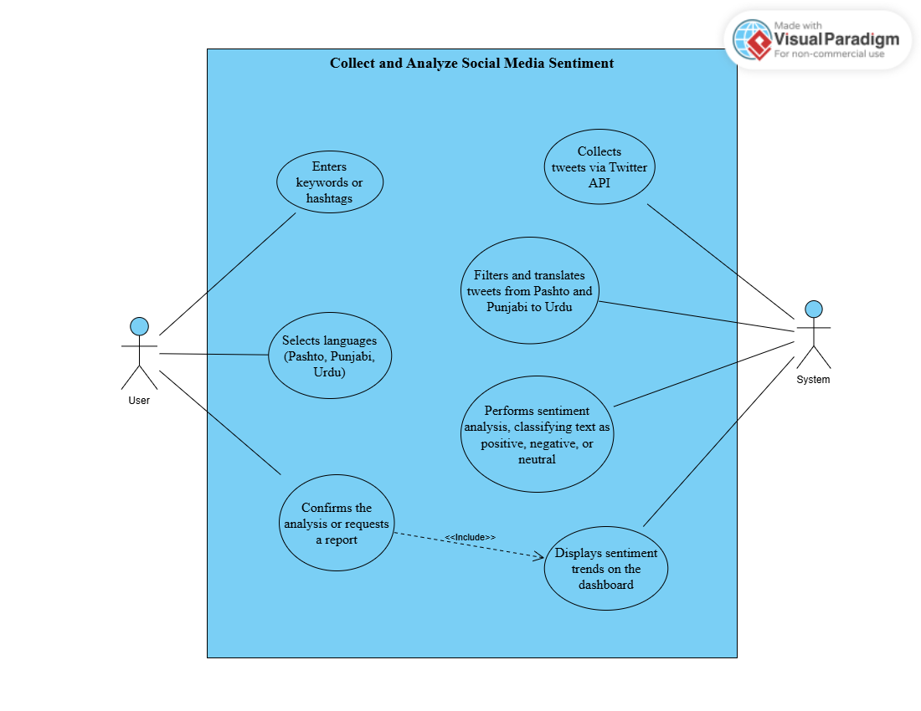
Figure 1 Use Case Diagram 01

Use Case 2: Generate and Export Sentiment Report

Use Case ID: | UC-2
UC Name: | Generate and Export Sentiment Report
Actors: | Policymakers, NGOs, Researchers (Users)
Description: | A user generates a detailed report of sentiment analysis results for a specific social issue and exports it in PDF or CSV format for further use.
Trigger: | A user requests a sentiment report after viewing trends on the dashboard.
Preconditions: | PRE-1. User is logged into the PakSentiment system.  PRE-2. Sentiment analysis data is available.
Postconditions: | POST-1. A report containing sentiment trends is generated.  POST-2. Report is exported and stored in the system.
Normal Flow: | - User selects a social issue and date range on the dashboard.  - System filters sentiment data based on user input.  - System generates a report with visualized trends and summary statistics.  - User chooses export format (PDF or CSV).  - System exports the report and sends a confirmation email.  - System stores the report for future access.
Alternative Flows: | 2.1 No Data Available  - If no data exists for the selected range, the system notifies the user.  - User adjusts date range or cancels.  2.2 Multiple Issues  - User selects multiple social issues.  - System generates a consolidated report.  - 3. Return to step
Exceptions: | E1- Export Failure  - System notifies user of export error (e.g., file size limit).  - If user retries, the system attempts export again.  - Else if user cancels, the system terminates the use case.  E2- Email Failure  - System logs the error and stores the report without sending email.  - User retrieves report manually.
Business Rules: | BR-1. Reports must include interactive visualizations.  BR-2. Export must be completed within 5 minutes.
Assumptions: | 1. Assume users prefer PDF format for 70% of exports (Source: User survey).

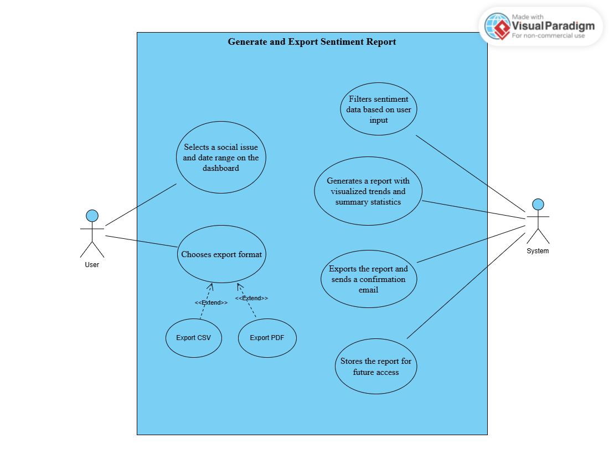
Figure 2 Use Case diagram 2

Use Case 3: Evaluate and Improve Translation Model

Use Case ID: | UC-3
UC Name: | Evaluate and Improve Translation Model
Actors: | Administrators, Linguistic Experts, Data Scientists
Description: | An administrator evaluates the performance of the translation model and collaborates with linguistic experts to improve its accuracy.
Trigger: | An administrator initiates a model evaluation after a scheduled interval or performance drop.
Preconditions: | PRE-1. Administrator is logged into the PakSentiment system.  PRE-2. Translation model is trained with initial data.
Postconditions: | POST-1. Model evaluation results are recorded.  POST-2. Improved model is deployed if performance meets thresholds.
Normal Flow: | - Administrator triggers evaluation using automated metrics (e.g., BLEU, TER).  - System sends translated text samples to linguistic experts for review.  - Experts provide feedback on fluency and adequacy.  - Administrator analyzes results and identifies improvement areas.  - System refines the model with additional data or hyperparameter tuning.  - Improved model is tested and deployed.
Alternative Flows: | 3.1 Expert Unavailable  - If no feedback is received within 48 hours, the system proceeds with automated metrics.  - Return to step 4.  3.2 Minor Improvements  - If improvements are below threshold, the system schedules a follow-up evaluation.  - Return to step 1.
Exceptions: | E1- Model Evaluation Failure  - System notifies administrator of metric calculation error.  - If administrator retries, the system reattempts evaluation.  - Else if administrator cancels, the use case terminates.  E2- Data Insufficiency  - System alerts administrator of insufficient data.  - Administrator adds data and returns to step 1.
Business Rules: | BR-1. Evaluation must occur monthly.  BR-2. Improvement must achieve at least a 5% accuracy increase.
Assumptions: | 1. Assume 80% of translation errors are due to data quality (Source: Initial model analysis).

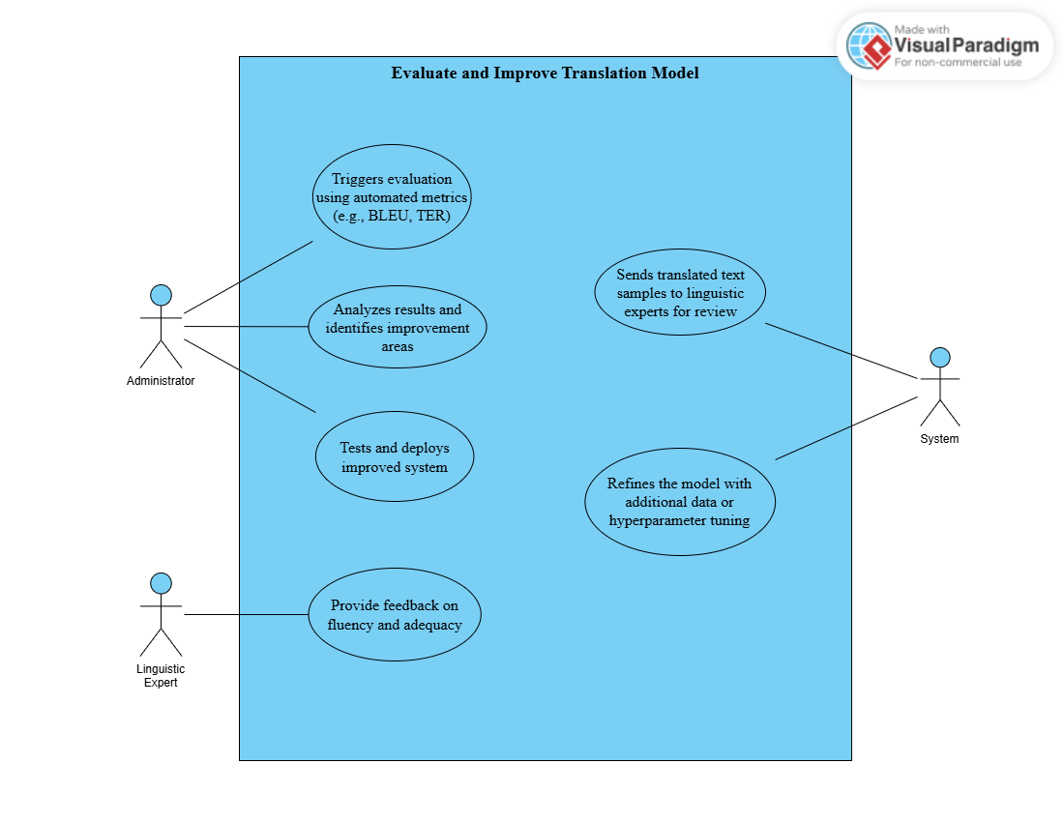
Figure 3 Use Case diagram 3

Use Case 4: Monitor Real-Time Data Collection

Use Case ID: | UC-4
UC Name: | Monitor Real-Time Data Collection
Actors: | Administrators, Twitter API, Internet Data Sources
Description: | An administrator monitors the real-time collection of social media and internet data to ensure continuous operation and data availability.
Trigger: | An administrator initiates monitoring or the system detects a data collection event.
Preconditions: | PRE-1. Administrator is logged into the PakSentiment system.  PRE-2. Data collection services are active.
Postconditions: | POST-1. Collected data is stored and flagged for processing.  POST-2. Monitoring logs are updated.
Normal Flow: | - Administrator activates real-time monitoring.  - System collects tweets via Twitter API and internet data.  - System filters data by language (Pashto, Punjabi, Urdu).  - System stores data and updates monitoring logs.  - 5. Administrator reviews logs for anomalies.
Alternative Flows: | 2.1 Partial Data Collection  - If internet data is unavailable, the system relies on Twitter data.  - Return to step 3.  2.2 Manual Override  - Administrator pauses collection to adjust settings.  - Return to step 1.
Exceptions: | E1- API Disconnection  - System notifies administrator of Twitter API failure.  - If administrator reconnects, the system resumes.  - Else if administrator switches to cached data, the use case continues.  E2- Storage Limit  - System alerts administrator of storage overflow.  - Administrator clears old data and returns to step 4.
Business Rules: | BR-1. Monitoring must run continuously.  BR-2. Data collection must process at least 100 items per hour.
Assumptions: | 1. Assume 90% of data is collected via Twitter (Source: Initial deployment data).
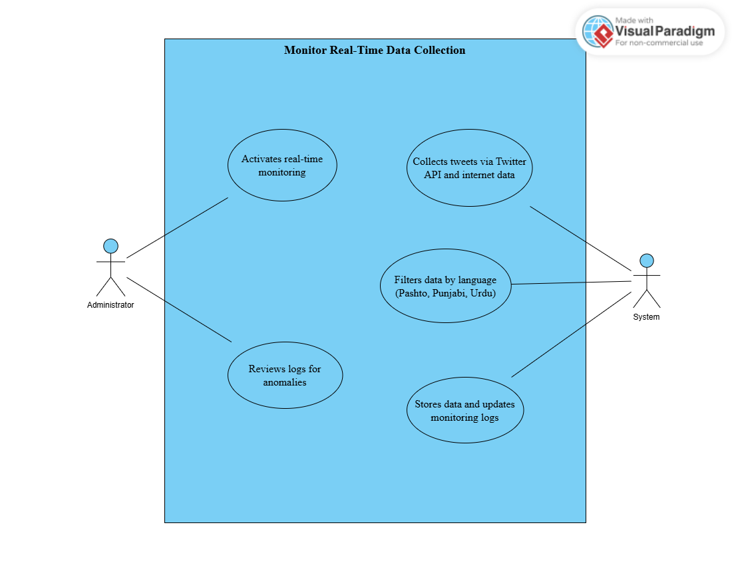
Figure 4 Use Case diagram 4

Use Case 5: Manage User Accounts

Use Case ID: | UC-5
UC Name: | Manage User Accounts
Actors: | Administrators, Users (Policymakers, NGOs, Researchers)
Description: | An administrator creates, updates, or deletes user accounts to control access to the PakSentiment system, ensuring only authorized users can analyze sentiment data.
Trigger: | An administrator needs to manage user accounts (e.g., onboard a new researcher or update access levels).
Preconditions: | PRE-1. Administrator is logged into the system with administrative privileges.  PRE-2. User management module is accessible.
Postconditions: | POST-1. User accounts are created, updated, or deleted as per the administrator's actions.  POST-2. System logs reflect the changes for audit purposes.
Normal Flow: | - Administrator navigates to the user management section.  - Administrator selects an option: create, update, or delete a user account.  - For creation: Administrator enters user details (name, email, role) and assigns access level (e.g., viewer, analyst).  - For update: Administrator selects an existing user, modifies details or access level, and saves changes.  - For deletion: Administrator selects a user and confirms deletion.  - System updates the user database and logs the action.
Alternative Flows: | - Bulk User Creation: Administrator uploads a CSV file with multiple user details; system validates and creates accounts.  - Soft Delete: Instead of deletion, the system deactivates the user account.
Exceptions: | E1- Duplicate User: System detects an existing user with the same email; administrator can override or cancel.  E2- Invalid Role: System detects an invalid role assignment; administrator corrects and retries.
Business Rules: | BR-1. All user accounts must be verified via email within 24 hours of creation.  BR-2. Access levels must be assigned based on predefined roles (viewer, analyst, admin) with no custom roles allowed.  BR-3. User deletion must be logged with a reason provided by the administrator.
Assumptions: | - Assume 90% of users will be onboarded within the first month of deployment (Source: Projected user growth).  - Assume administrators will manage an average of 10 user accounts per week (Source: Initial administrative load estimate).

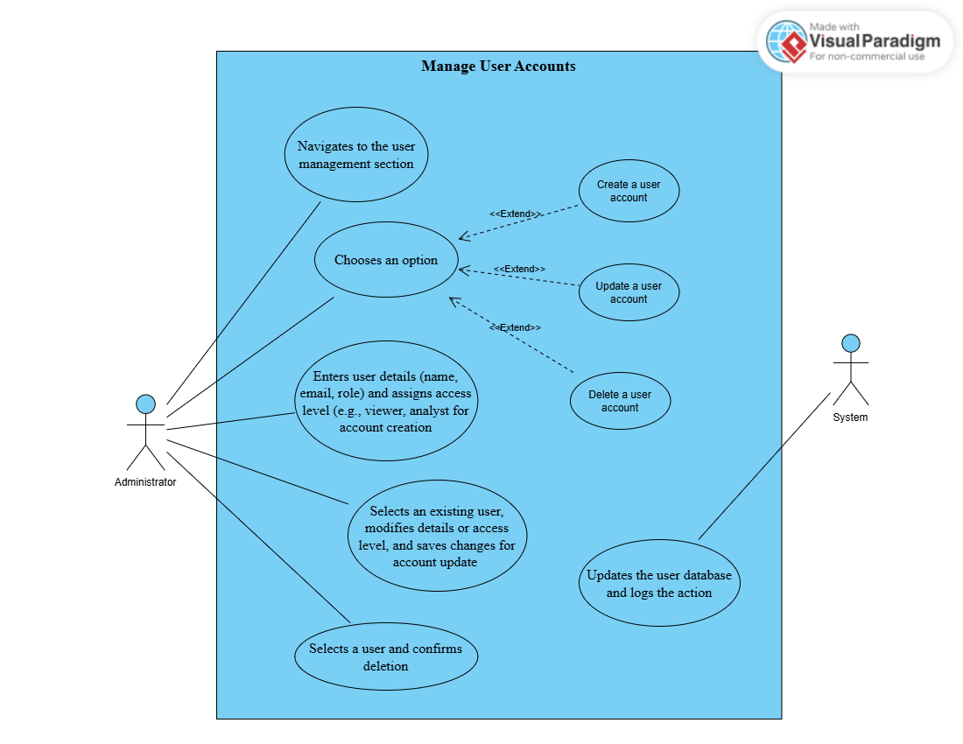
Figure 5 Use Case diagram 5

Use Case 6: Analyze Sentiment Over Time

Use Case ID: | UC-6
UC Name: | Analyze Sentiment Over Time
Actors: | Policymakers, NGOs, Researchers (Users)
Description: | A user analyzes how public sentiment on a specific social issue (e.g., education) has evolved over a selected time period, using visualizations to identify trends.
Trigger: | A user wants to observe sentiment trends for decision-making or research purposes.
Preconditions: | PRE-1. User is logged into the system.  PRE-2. Sentiment data for the selected social issue is available for the chosen time period.
Postconditions: | POST-1. Sentiment trends are displayed in a time-series graph.  POST-2. User can interact with the graph (e.g., zoom, filter).
Normal Flow: | - User selects a social issue (e.g., education) from the dashboard.  - User specifies a time period (e.g., last 6 months).  - System retrieves sentiment data for the selected issue and time frame.  - System displays a line graph showing sentiment (positive, negative, neutral) over time.  - User interacts with the graph to zoom in on specific periods or view detailed data points.  - User saves the graph or exports the data for further analysis.
Alternative Flows: | - Compare Multiple Issues: User selects multiple social issues (e.g., education and healthcare); system displays a comparative graph.  - Change Graph Type: User switches from line graph to bar chart for better visualization.
Exceptions: | E1- No Data for Time Period: System informs user no data is available; user adjusts the time period or cancels.  E2- Visualization Error: System fails to render the graph due to data overload; user reduces the time period and retries.
Business Rules: | BR-1. The system must render the time-series graph within 10 seconds of user request.  BR-2. The maximum time period for analysis is limited to 12 months to ensure performance.  BR-3. Exported data must include metadata (e.g., date, social issue) for traceability.
Assumptions: | - Assume 60% of users will analyze sentiment over a 3-month period (Source: User preference survey).  - Assume historical data completeness is at least 80% for the past 6 months (Source: Initial data collection rate).
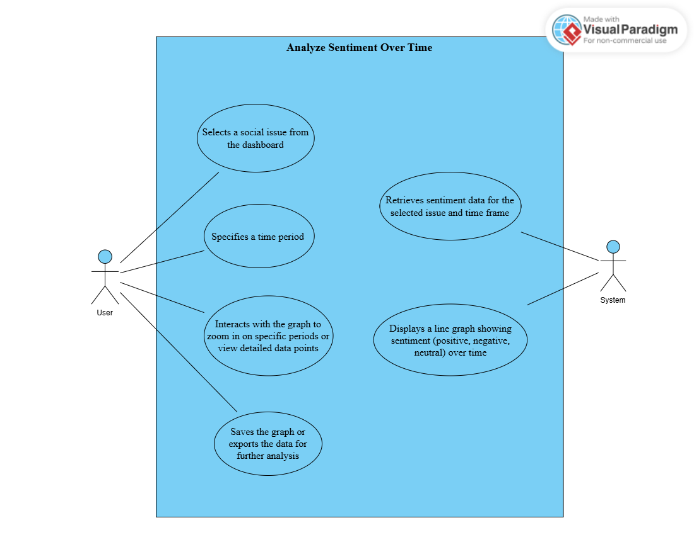
Figure 6 Use Case diagram 6

Use Case 7: Handle Translation Errors

Use Case ID: | UC-7
UC Name: | Handle Translation Errors
Actors: | Administrators, Linguistic Experts
Description: | An administrator identifies and manages translation errors by sending erroneous translations to linguistic experts for correction, ensuring the quality of sentiment analysis.
Trigger: | An administrator detects translation errors during routine checks or user feedback.
Preconditions: | PRE-1. Administrator is logged into the system.  PRE-2. Translation errors are flagged in the system.
Postconditions: | POST-1. Erroneous translations are corrected and updated in the system.  POST-2. Model is retrained with corrected data if necessary.
Normal Flow: | - Administrator navigates to the translation error management section.  - Administrator reviews flagged translations.  - Administrator selects erroneous translations and sends them to linguistic experts for correction.  - Linguistic experts correct the translations and provide feedback.  - Administrator reviews corrections and applies them to the system.  - System updates the translated text and retrains the translation model if corrections exceed a threshold.
Alternative Flows: | - Expert Feedback Delay: If experts don’t respond within 48 hours, the system escalates the request.  - Partial Corrections: Administrator applies corrections to only a subset of translations.
Exceptions: | E1- No Experts Available: System notifies administrator; administrator assigns to another expert or skips.  E2- Invalid Corrections: System detects invalid corrections (e.g., non-Urdu text); administrator reassigns the task.
Business Rules: | BR-1. Translation errors must be reviewed and corrected within 72 hours of detection.  BR-2. The system must flag at least 95% of translation errors automatically.  BR-3. Model retraining must occur only if more than 10% of translations are corrected.
Assumptions: | - Assume 15% of translations will require manual correction initially (Source: Initial model accuracy test).  - Assume linguistic experts are available for at least 80% of error correction requests (Source: Expert availability estimate).
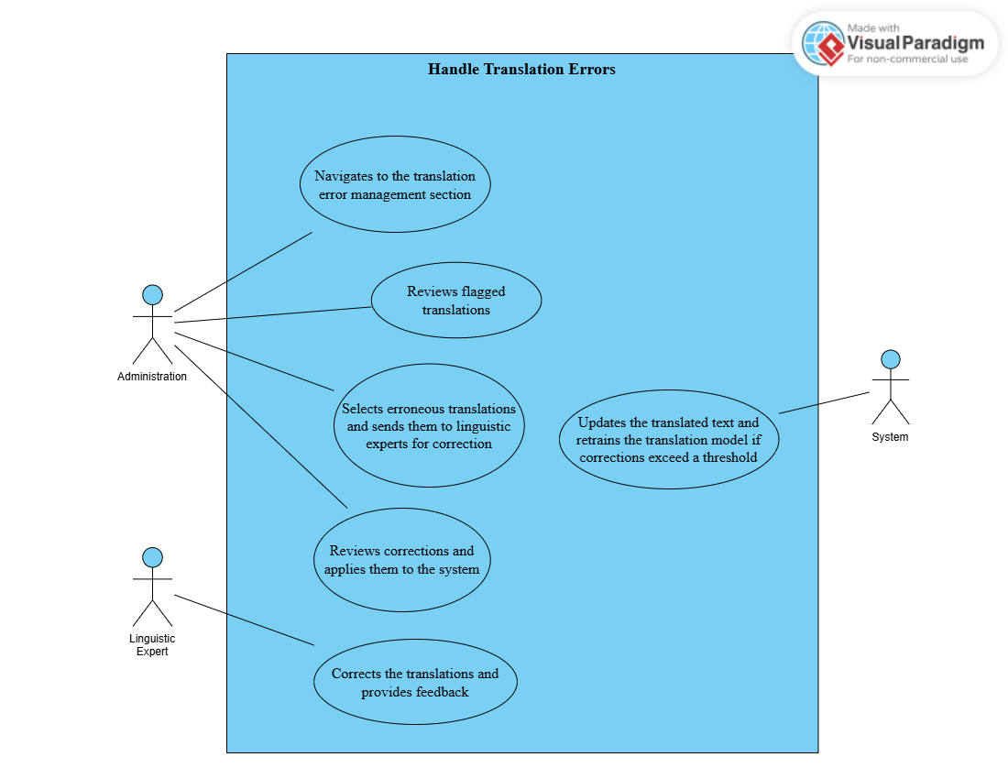
Figure 7 Use Case diagram 7

Functional Requirements

Module 1: Data Collection

FR-1: Collect Tweets
Table 1: Description of FR-1
Identifier | FR-1
Title | Collect Tweets
Requirement | The system shall collect tweets using the Twitter API based on specific keywords and hashtags.
Source | Use Case 1 and event response table.
Rationale | To gather relevant social media data for sentiment analysis.
Business Rule (if required) | Tweets must be in Pashto, Punjabi, Urdu, or English.
Dependencies | None
Priority | High

FR-2: Collect Internet Data
Table 2: Description of FR-2

Identifier | FR-2
Title | Collect Internet Data
Requirement | The system shall collect text data from various internet sources in the required languages.
Source | Use Case 1
Rationale | To enhance the dataset with diverse text sources.
Business Rule | Data must be text-based and in specified languages.
Dependencies | None
Priority | Medium

FR-3: Collect Literature Data
Table 3: Description of FR-3

Identifier | FR-3
Title | Collect Literature Data
Requirement | The system shall collect text data from books in Pashto, Punjabi, and Urdu to reveal script nuances.
Source | Use Case 1 and Use Case 2.
Rationale | To improve translation model accuracy with linguistic diversity.
Business Rule | Data must be from published literature.
Dependencies | None
Priority | Low

Module 2: Data Filtration

FR-4: Filter Tweets by Language

Table 4: Description of FR-4

Identifier | FR-4
Title | Filter Tweets by Language
Requirement | The system shall filter tweets to retain only those in Pashto, Punjabi, and Urdu.
Source | Event response table and Use Case 2
Rationale | To focus analysis on relevant languages.
Business Rule | Non-specified languages shall be discarded.
Dependencies | FR-1
Priority | High

FR-5: Shape Internet Data
Table 5: Description of FR-5

Identifier | FR-5
Title | Shape Internet Data
Requirement | The system shall format internet-collected data into sentences.
Source | Use Case 3.
Rationale | To prepare data for translation and analysis.
Business Rule | Formatting must preserve original meaning.
Dependencies | FR-2
Priority | Medium

FR-6: Filter Shaped Internet Data

Table 6: Description of FR-6

Identifier | FR-6
- Title | - Filter Shaped Internet Data
Requirement | The system shall filter shaped internet data to retain only Pashto, Punjabi, and Urdu content.
Source | Use Case 3 and Use Case 4.
Rationale | To ensure data relevance for analysis.
Business Rule | Non-specified languages shall be discarded.
Dependencies | FR-5
Priority | Medium

FR-7: Shape Literature Data
Table 7: Description of FR-7

Identifier | FR-7
Title | Shape Literature Data
Requirement | The system shall format literature data into sentences.
Source | Use Case 3 and Use Case 4.
Rationale | To prepare data for model training.
Business Rule | Formatting must preserve original meaning.
Dependencies | FR-3
Priority | Low

Module 3: Translation

FR-8: Clean and Preprocess Text

Table 8: Description of FR-8

Identifier | FR-8
Title | Clean and Preprocess Text
Requirement | The system shall clean and preprocess text data by removing emojis and URIs.
Source | Use Case 4 and Use Case 6.
Rationale | To ensure text is suitable for translation.
Business Rule | Preprocessing must not alter semantic content.
Dependencies | FR-4, FR-6, FR-7
Priority | High

FR-9: Translate Text
Table 9: Description of FR-9

Identifier | FR-9
Title | Translate Text
Requirement | The system shall translate Pashto and Punjabi text to Urdu using an NMT model.
Source | Use Case 5 and Use Case 6
Rationale | To standardize text for sentiment analysis.
Business Rule | Translation must maintain contextual accuracy.
Dependencies | FR-8
Priority | High

FR-10: Manage Translation Quality

Table 10: Description of FR-10

Identifier | FR-10
Title | Manage Translation Quality
Requirement | The system shall verify translation quality with linguistic experts.
Source | Use Case 7 and Event response table.
Rationale | To ensure high translation accuracy.
Business Rule | Quality must meet predefined standards.
Dependencies | FR-9
Priority | High

Module 4: Sentiment Analysis

FR-12: Preprocess Translated Text

Table 12: Description of FR-12

Identifier | FR-12
Title | Preprocess Translated Text
Requirement | The system shall preprocess translated Urdu text for sentiment classification.
Source | Use Case 4.
Rationale | To prepare text for accurate sentiment analysis.
Business Rule | Preprocessing must preserve sentiment indicators.
Dependencies | FR-9
Priority | High

FR-13: Classify Sentiment
Table 13: Description of FR-13

Identifier | FR-13
Title | Classify Sentiment
Requirement | The system shall classify Urdu text as positive, negative, or neutral using a sentiment analysis model.
Source | Event response table and Use Case 4.
Rationale | To identify public sentiment trends.
Business Rule | Classification must account for Urdu linguistic nuances.
Dependencies | FR-12
Priority | High

FR-14: Store Sentiment Labels

Table 14: Description of FR-14

Identifier | FR-14
Title | Store Sentiment Labels
Requirement | The system shall store sentiment labels with original and translated text.
Source | Use Case 5.
Rationale | To maintain records for analysis and reporting.
Business Rule | Storage must be secure and efficient.
Dependencies | FR-13
Priority | High

Module 5: Model Evaluation

FR-15: Evaluate Translation Model

Table 15: Description of FR-15

Identifier | FR-15
Title | Evaluate Translation Model
Requirement | The system shall evaluate the translation model using automated metrics named BLEU and TER.
Source | Use Case 2.
Rationale | To assess translation quality.
Business Rule | Evaluations must be periodic.
Dependencies | FR-9
Priority | Medium

FR-16: Human Evaluation
Table 16: Description of FR-16

Identifier | FR-16
Title | Human Evaluation
Requirement | The system shall support human evaluation of translation fluency and adequacy.
Source | Use Case 2.
Rationale | To complement automated metrics.
Business Rule | Evaluations must involve linguistic experts.
Dependencies | FR-9
Priority | Medium

Module 6: Model Improvement

FR-17: Improve Training Data

Table 17: Description of FR-17

Identifier | FR-17
Title | Improve Training Data
Requirement | The system shall enhance training data quality.
Source | Use Case 2.
Rationale | To improve model performance.
Business Rule | Data must meet quality standards.
Dependencies | FR-15, FR-16
Priority | Medium

FR-18: Increase Data Volume

Table 18: Description of FR-18

Identifier | FR-18
Title | Increase Data Volume
Requirement | The system shall expand data volume to improve model accuracy.
Source | Event Response Table and Use Case 6.
Rationale | To enhance model generalization.
Business Rule | Data must be relevant and diverse.
Dependencies | FR-17
Priority | Medium

FR-19: Experiment with Pretrained Models

Table 19: Description of FR-19

Identifier | FR-19
Title | Experiment with Pretrained Models
Requirement | The system shall test various pretrained models to optimize performance.
Source | Use Case 7.
Rationale | To select the best model.
Business Rule | Models must be compatible with system architecture.
Dependencies | FR-15, FR-16
Priority | Medium

FR-20: Optimize Training Process

Table 20: Description of FR-20

Identifier | FR-20
Title | Optimize Training Process
Requirement | The system shall optimize training through hyperparameter tuning and curriculum learning.
Source | Use Case 3.
Rationale | To enhance model efficiency.
Business Rule | Training must be resource-efficient.
Dependencies | FR-17, FR-18, FR-19
Priority | Medium

Module 7: Visualization

FR-21: Dashboard for Sentiment Trends

Table 21: Description of FR-21

Identifier | FR-21
Title | Dashboard for Sentiment Trends
Requirement | The system shall provide a dashboard to visualize sentiment trends over time.
Source | Event response table and use Case 4.
Rationale | To enable users to interpret sentiment data easily.
Business Rule | Dashboard must be interactive.
Dependencies | FR-14
Priority | High

FR-22: Filtering Options

Table 22: Description of FR-22

Identifier | FR-22
Title | Filtering Options
Requirement | The system shall allow filtering by social issue, language, and date range.
Source | Use case 1.
Rationale | To provide targeted insights.
Business Rule | Filters must be responsive.
Dependencies | FR-21
Priority | High

FR-23: Export Reports

Table 23: Description of FR-23

Identifier | FR-23
Title | Export Reports
Requirement | The system shall enable report export in PDF or CSV format.
Source | Use Case 2.
Rationale | To facilitate data sharing.
Business Rule | Reports must be professionally formatted.
Dependencies | FR-21
Priority | High

Module 8: Service Manager

FR-24: Monitor Data
Table 24: Description of FR-24

Identifier | FR-24
Title | Monitor Data
Requirement | The system shall monitor and collect data in real-time.
Source | Use Case 4.
Rationale | To ensure up-to-date analysis.
Business Rule | Monitoring must be efficient.
Dependencies | FR-1, FR-2, FR-3
Priority | High

FR-25: Manage User Data

Table 25: Description of FR-25

Identifier | FR-25
Title | Manage User Data
Requirement | The system shall securely store and manage user data and sessions.
Source | Use Case 5.
Rationale | To protect user privacy.
Business Rule | Must comply with data protection regulations.
Dependencies | None
Priority | High

FR-26: Store Reports

Table 26: Description of FR-26

Identifier | FR-26
Title | Store Reports
Requirement | The system shall store generated reports for future access.
Source | Use Case 5 and event response table.
Rationale | To allow retrieval of historical data.
Business Rule | Reports must be organized and accessible.
Dependencies | FR-23
Priority | Medium

Non-Functional Requirements
This section specifies nonfunctional requirements other than constraints, which are recorded in section 2.3, and external interface requirements, which will appear in section 7.

Reliability
REL-1 | The system shall have a mean time between failures (MTBF) of at least 30 days.
REL-2 | The system shall automatically recover from network failures within 1 minute.
REL-3 | The system shall perform daily backups of all data.
REL-4 | The system shall have an uptime of at least 99.5%.
REL-5 | The system shall implement automated health checks every 15 minutes to detect and resolve issues proactively.

Usability
USE-1 | The system shall provide a user interface that allows new users to perform basic tasks without training.
USE-2 | The system shall display error messages in plain language, suggesting corrective actions.
USE-3 | The system shall support accessibility features compliant with WCAG 2.1 Level AA.
USE-4 | The system shall support user interfaces in English and Urdu.
USE-5 | The system shall provide comprehensive user documentation and help guides in both English and Urdu.
.

Performance
PER-1 | The system shall process a batch of 100 tweets, including translation and sentiment analysis, in under 5 minutes.
PER-2 | The dashboard shall load within 3 seconds for users with a standard internet connection.
PER-3 | The system shall support up to 50 concurrent users without degradation in performance.
PER-4 | The system shall be designed to scale horizontally to handle increased data loads.
PER-5 | The system shall respond to user queries (e.g., filtering sentiment data) within 2 seconds.
.

Security
SEC-1 | The system shall encrypt all data in transit using TLS 1.2 or higher.
SEC-2 | The system shall encrypt sensitive data at rest using AES-256 encryption.
SEC-3 | The system shall require two-factor authentication for all user logins.
SEC-4 | The system shall implement role-based access control (RBAC) to restrict data access based on user roles.
SEC-5 | The system shall comply with relevant data protection regulations, including Pakistan's data privacy laws.

Maintainability
MAIN-1 | The system shall be designed with a modular architecture to facilitate updates to individual components (e.g., translation model, sentiment analysis).
MAIN-2 | The system shall include comprehensive technical documentation, including API specifications and code comments.
MAIN-3 | The system shall support automated testing for at least 80% of its codebase.
MAIN-4 | The system shall allow for model updates (e.g., retraining the translation model) without downtime.

Scalability

SCAL-1 | The system shall support horizontal scaling to accommodate up to 10,000 tweets per hour.
SCAL-2 | The system shall utilize load balancing to distribute processing across multiple servers.
SCAL-3 | The system shall be capable of scaling storage capacity by at least 50% without service interruption.

Compliance
COMP-1 | The system shall comply with Pakistan's Electronic Transactions Ordinance for data handling.
COMP-2 | The system shall adhere to ethical guidelines for AI and data usage, ensuring unbiased sentiment analysis.
COMP-3 | The system shall provide audit logs for all data access and modifications.

Data Integrity
INTG-1 | The system shall validate all incoming data for completeness and format consistency.
INTG-2 | The system shall implement checksums or hashes to detect data corruption during storage and transmission.
INTG-3 | The system shall maintain data versioning for all updates to translation and sentiment models.

Privacy
PRIV-1 | The system shall not store any personally identifiable information (PII) from social media data beyond what is necessary for analysis.
PRIV-2 | The system shall provide users with the ability to delete their account and associated data upon request.
PRIV-3 | The system shall inform users of data usage policies through a clear privacy notice.

Interoperability
INTER-1 | The system shall provide APIs for exporting sentiment data in JSON or CSV formats.
INTER-2 | The system shall support integration with common data analysis tools (e.g., Excel, Tableau).
INTER-3 | The system shall be compatible with standard authentication protocols (e.g., OAuth 2.0).

Resilience
RES-1 | The system shall implement failover mechanisms to switch to backup servers within 30 seconds of a failure.
RES-2 | The system shall support data replication across multiple geographic locations.
RES-3 | The system shall have a disaster recovery plan with a recovery time objective (RTO) of 4 hours.

Accessibility
ACC-1 | The system shall support screen readers and keyboard navigation for visually impaired users.
ACC-2 | The system shall be accessible from regions with low bandwidth (e.g., by optimizing data usage).
ACC-3 | The system shall provide offline access to previously generated reports.

Cost-Effectiveness
COST-1 | The system shall utilize open-source technologies where possible to minimize licensing costs.
COST-2 | The system shall be designed to optimize cloud resource usage, reducing operational costs.
COST-3 | The system shall provide cost monitoring tools for administrators to track resource consumption.

Adaptability
ADAPT-1 | The system shall support the integration of new sentiment analysis algorithms within 2 weeks of development completion.
ADAPT-2 | The system shall allow configuration of data sources (e.g., adding new social media platforms) without code changes.
ADAPT-3 | The system shall provide a plugin framework for extending visualization capabilities.

Portability
PORT-1 | The system shall be deployable on any major cloud provider (e.g., AWS, Azure, Google Cloud) with minimal configuration changes.
PORT-2 | The system shall support containerization using Docker for consistent deployment across environments.
PORT-3 | The system shall be compatible with both Linux and Windows server environments.

User Satisfaction
USAT-1 | The system shall achieve a user satisfaction score of at least 85% in post-deployment surveys.
USAT-2 | The system shall provide customizable dashboard layouts to meet individual user preferences.
USAT-3 | The system shall offer real-time feedback mechanisms (e.g., tooltips, progress indicators) during data processing.

External Interface Requirements
This section provides information to ensure that the system will communicate properly with users and with external hardware or software elements. A complex system with multiple subcomponents should create a separate interface specification or system architecture specification. The interface documentation could incorporate material from other documents by reference. For instance, it could point to a hardware device manual that lists the error codes that the device could send to the software.

User Interfaces Requirements
- The system shall provide a web interface compatible with major browsers.
- The system shall offer a mobile interface for iOS and Android.
- Interfaces shall adhere to a consistent design with standardized fonts and navigation.

Software interfaces
- SI-1: The system shall interface with the Twitter API for data collection.
- SI-2: The system shall connect to MongoDB for data storage.

Hardware interfaces
- Not applicable, as PakSentiment is a software-only system.

Communications interfaces

State the requirements for any communication functions the product will use, including email, web browser, network protocols, and electronic forms.

Example:

- CI-1: The system shall use HTTPS for secure data transmission.
- CI-2: The system shall support email notifications for report availability.

Design and Architecture
This chapter describes the overall system architecture and design of the PakSentiment system. It explains how the system is divided into modules and how these modules interact with each other to achieve the required functionality. The chapter also presents the design models used in system development, the data design of the system, and the human interface design that describes how users interact with the system.

Architectural Design
This architecture represents a high-performance, modular sentiment analysis pipeline:

- Presentation Layer (Next.js/React): The user-facing dashboard where requests are initiated and results are visualized. It communicates exclusively with the main backend via REST APIs.
- Application Layer (Nest.js): Acts as the "Brain" or API Gateway. It manages user authentication, business logic, and orchestrates the other two specialized backend services.
- Sidecar Scraper Layer (Go): A high-speed, parallelized service designed for real-time news and web scraping. It uses Go’s concurrency and the Colly framework for maximum throughput, caching raw results in Redis to avoid redundant network calls.
- Ingestion & Processing Layer (FastAPI): Specialized for Social Media (Nitter/Twitter/Reddit) and heavy data transformation. This layer handles the preprocessing, Urdu/English translation pipelines, and secondary sentiment classification.
- Data Layer (MongoDB/Postgres): The persistent storage where both the Go and Python services write their analyzed results ("ScrapedDocuments") so that the Nest.js server can aggregate them into reports for the user.
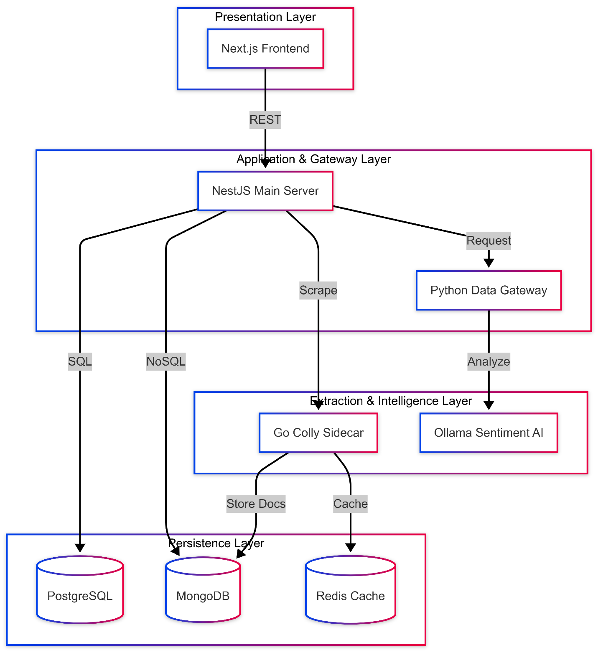
Figure 8 Architecture Diagram

Design Models
The system uses a combination of two methodologies, based on the function of each subsystem:
- Object-Oriented Programming (OOP): Used in the system's core, including the Nest.js Backend, FastAPI Ingestion Server, and Data Scraping Modules.
  - Justification: Supports modularity, reusability, and scalability.
  - Applicable Models: Class Diagram, System Sequence Diagrams (SSD), and Activity Diagrams.
- Procedural Programming : Used primarily for the Frontend (React components) where UI rendering is functional and event-driven.
  - Justification: Aligns with React's functional approach for cleaner component logic, predictable behavior, and easier state management.
  - Applicable Models: Data Flow Diagram and Activity Diagram

Process Model
The project follows the Incremental Process Model.
- Description: The system is developed in functional segments (increments), where each segment adds new capabilities.
- Justification: This model is ideal because the project consists of multiple independent modules (scraping, sentiment model, dashboard) with varying dependencies. It allows for early delivery of working subsystems and supports incremental testing and validation at every stage, reducing overall project risk.

Activity Diagrams
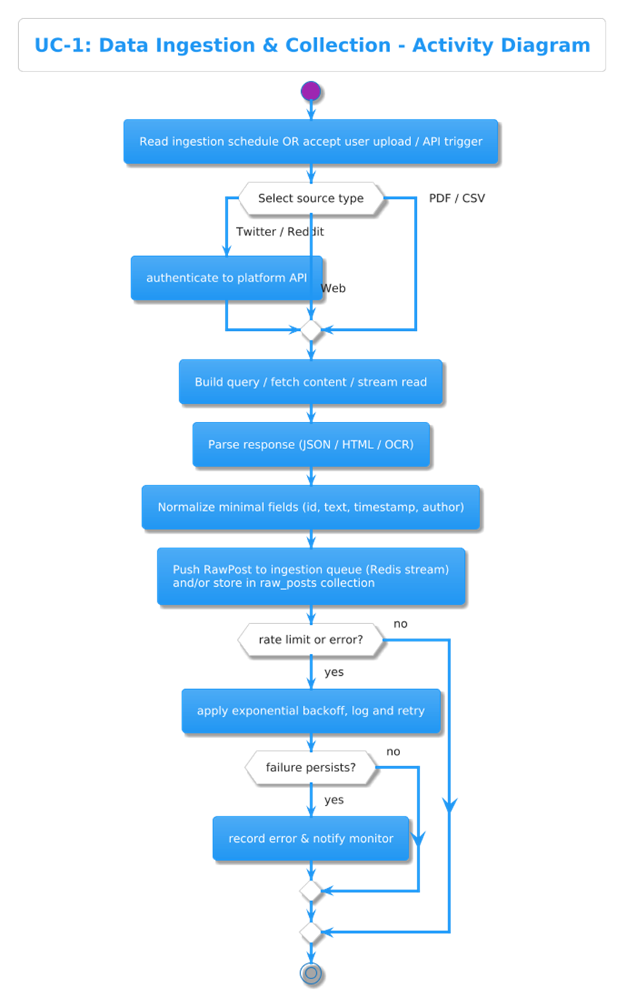
Figure 9 Activity diagram 01

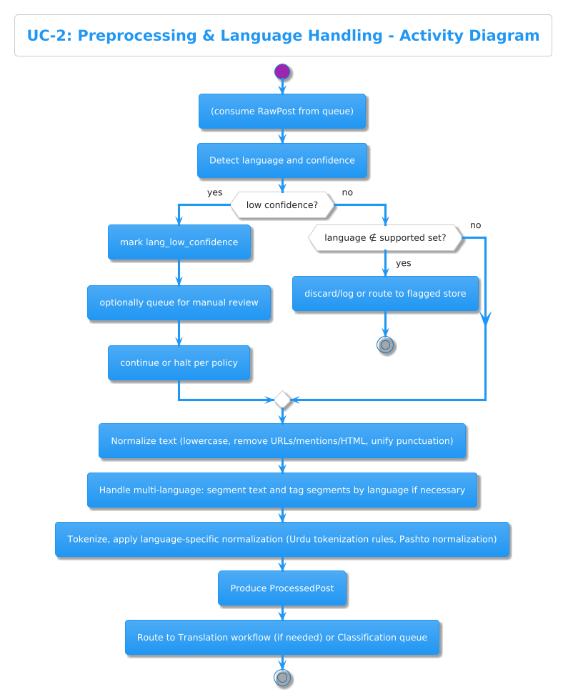
Figure 10 Activity diagram 02
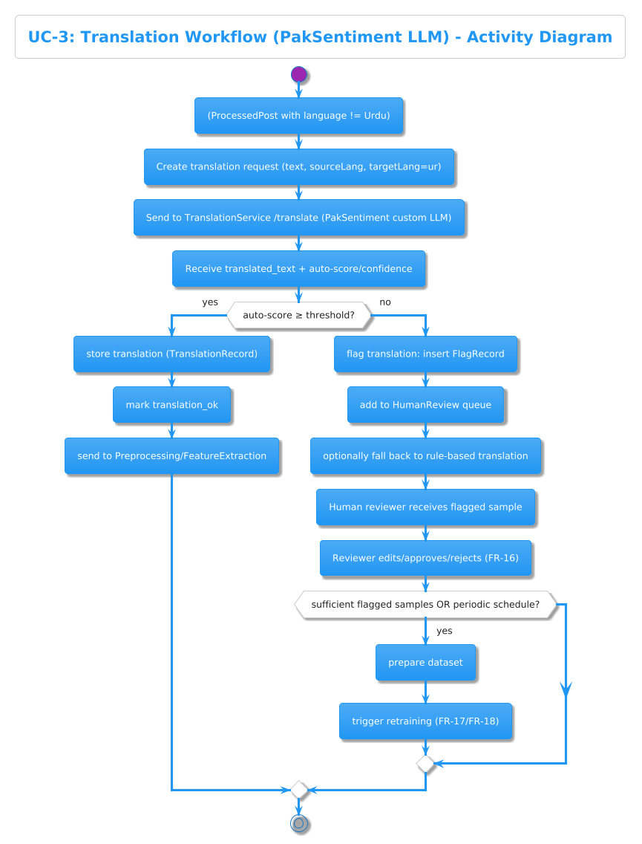
Figure 11 Activity diagram 03
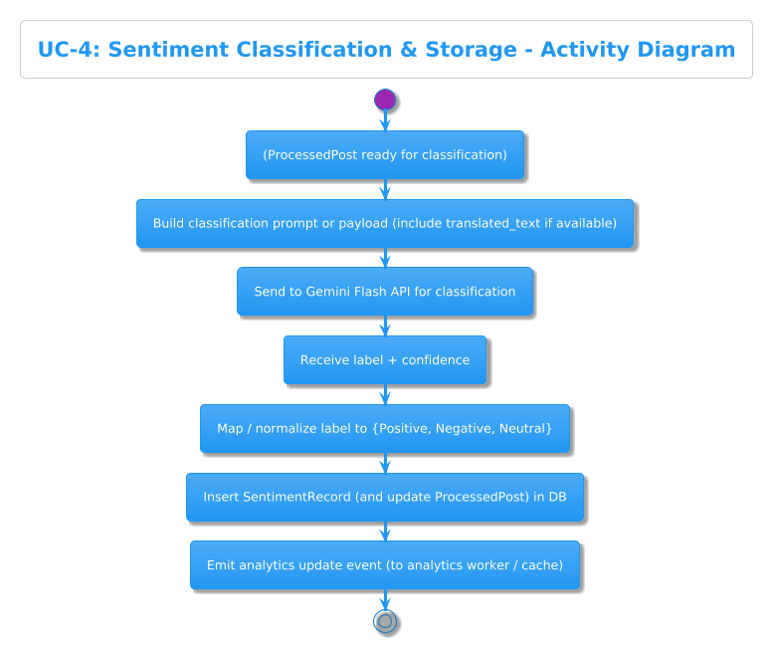
Figure 12 Activity diagram 04
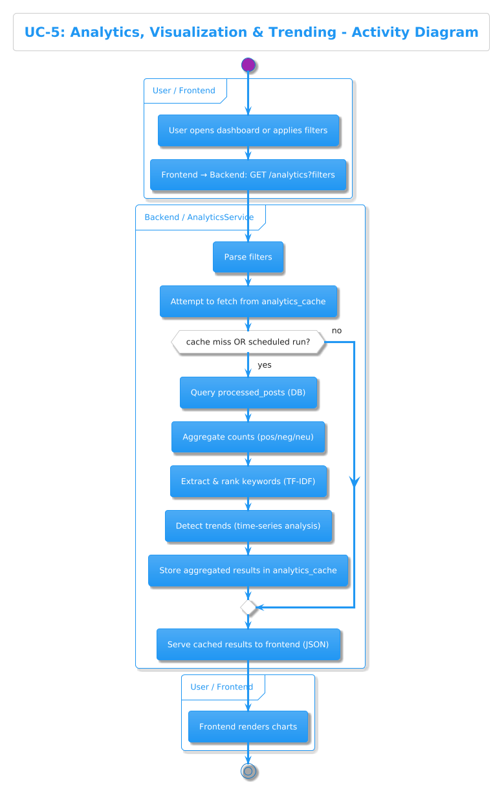
Figure 13 Activity diagram 05
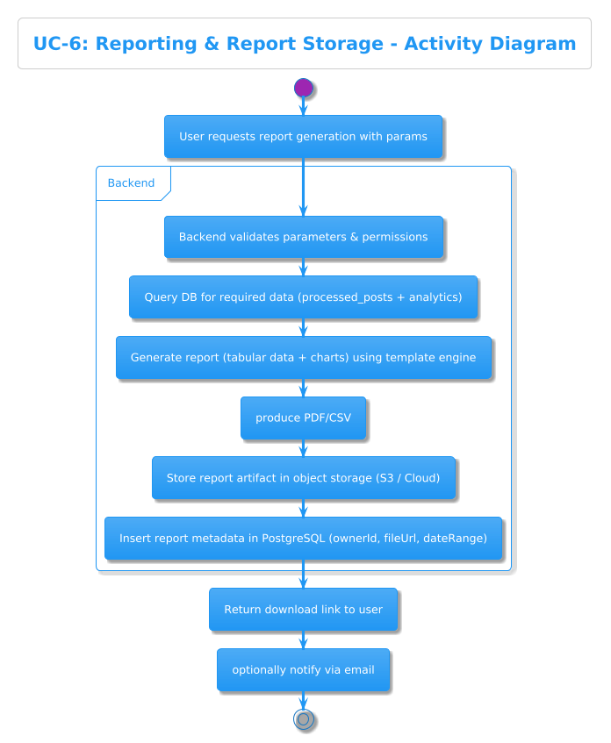
Figure 14 Activity diagram 06
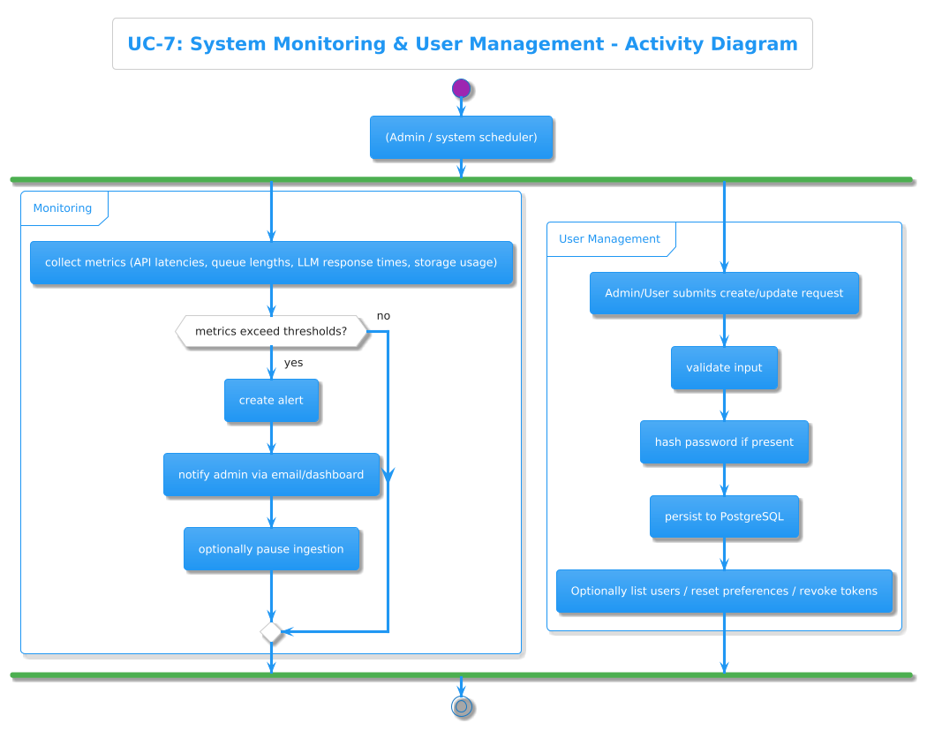
Figure 15 Activity diagram 07

Class Diagram:
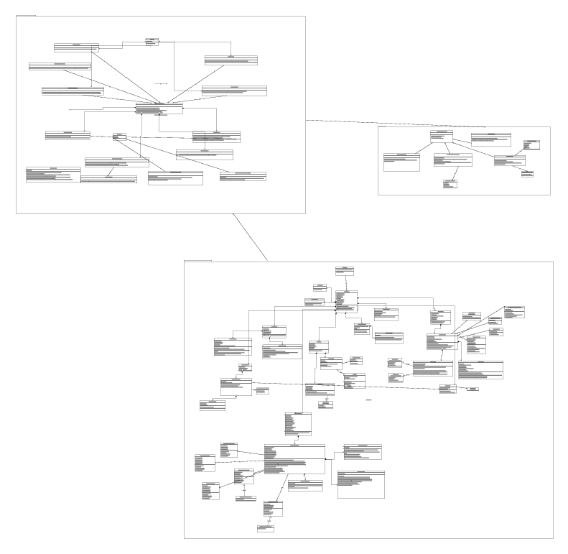
Figure 16 Class Diagram

Entity Relation Diagram:
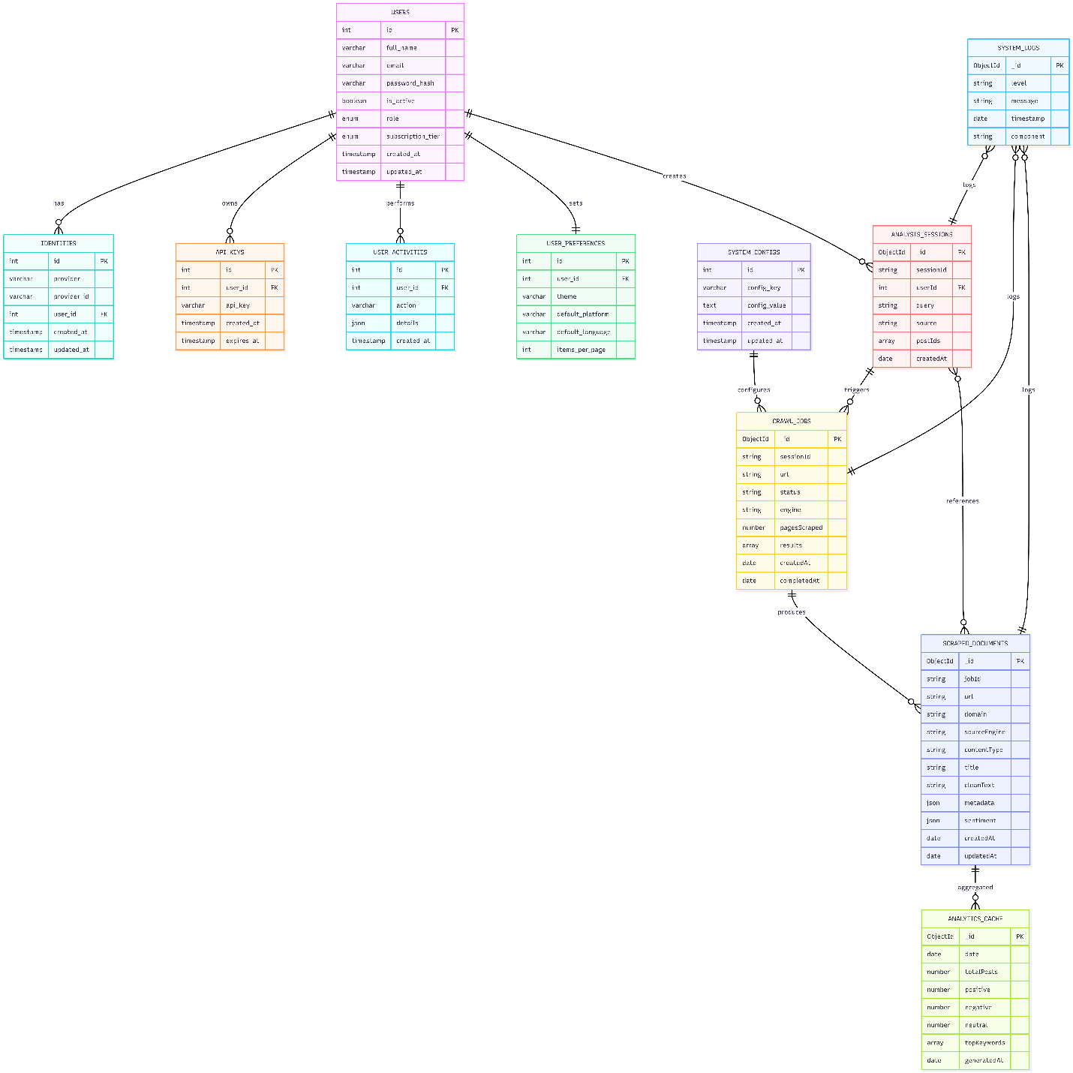
Figure 17 Entity Relation Diagram

DataFlow Diagrams upto level 2

Level 0 (context Level):

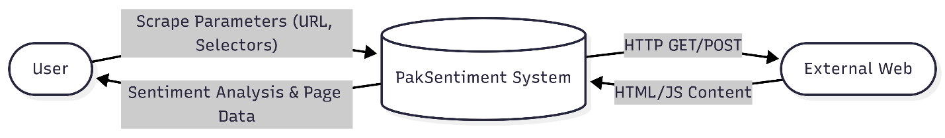
Figure 18 DFD level 0

Level 1 (Overview Diagram):

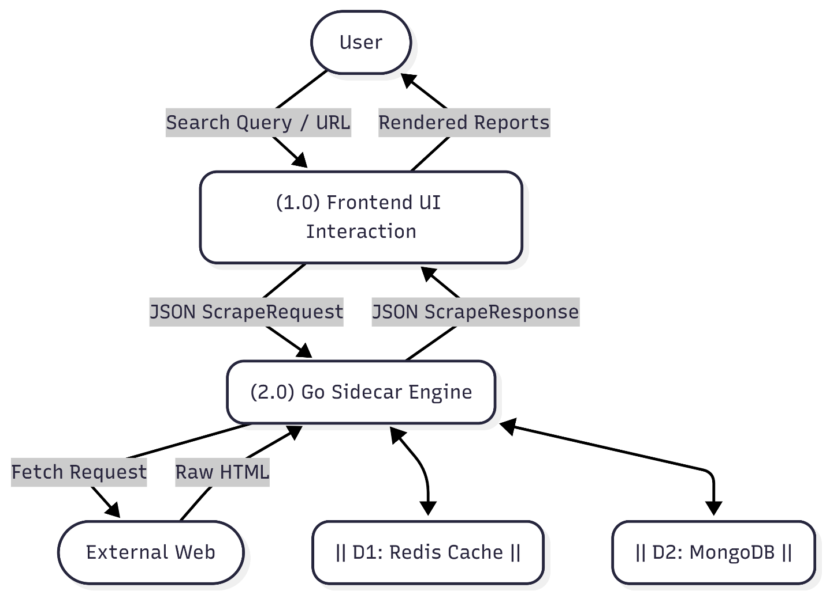
Figure 19 DFD level 01

Level 1 (Detailed component Diagram):
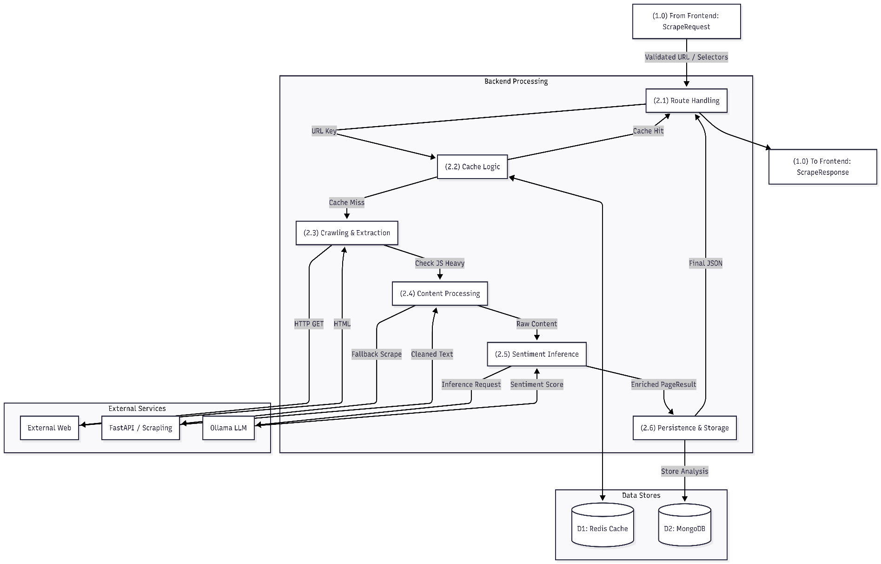
Figure 20 DFD level 02

System Sequence Diagrams:
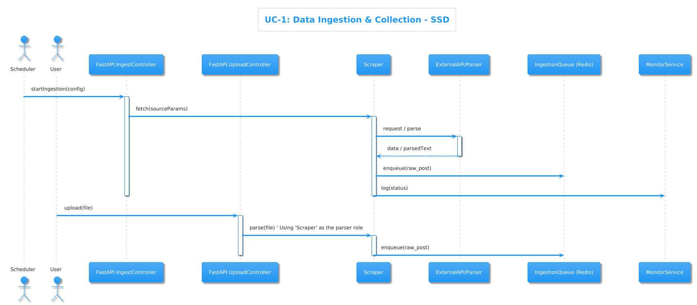
Figure 21 System Sequence 01
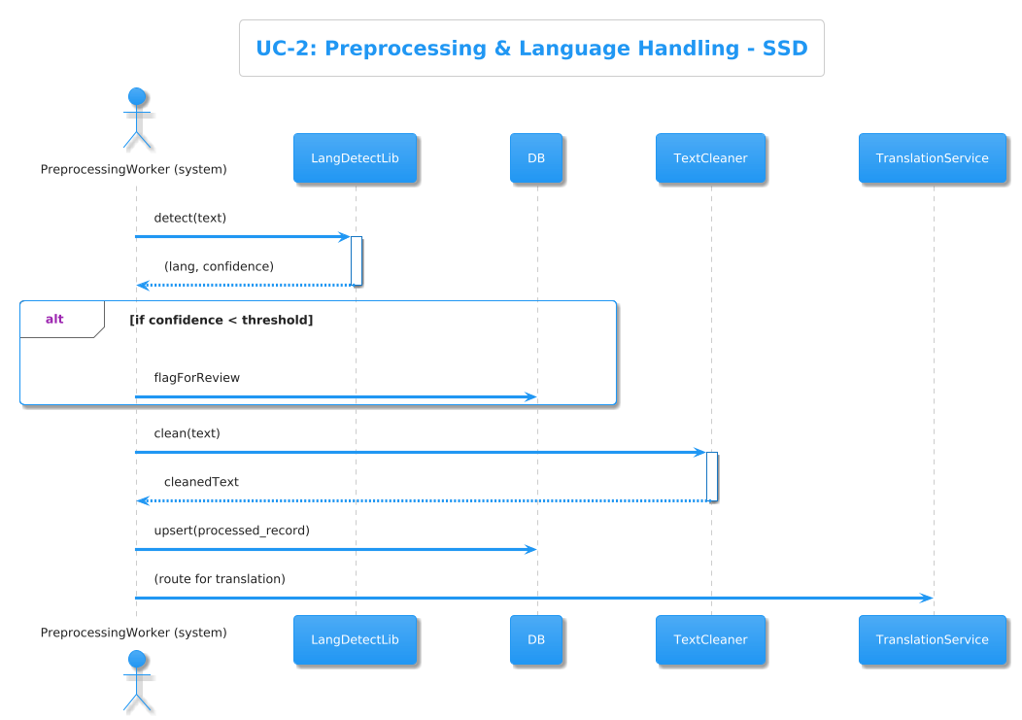
Figure 22 System Sequence 02
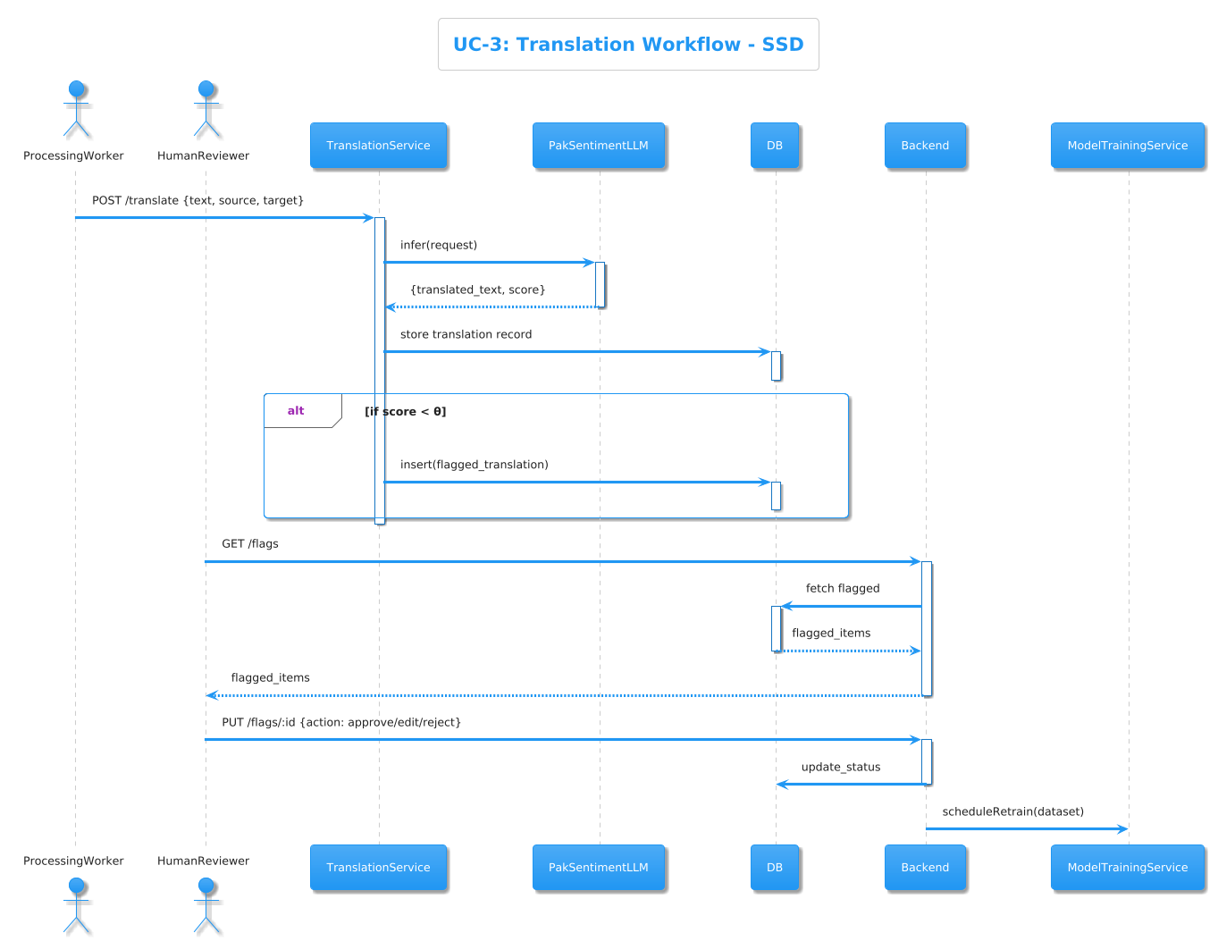
Figure 23 System Sequence 03
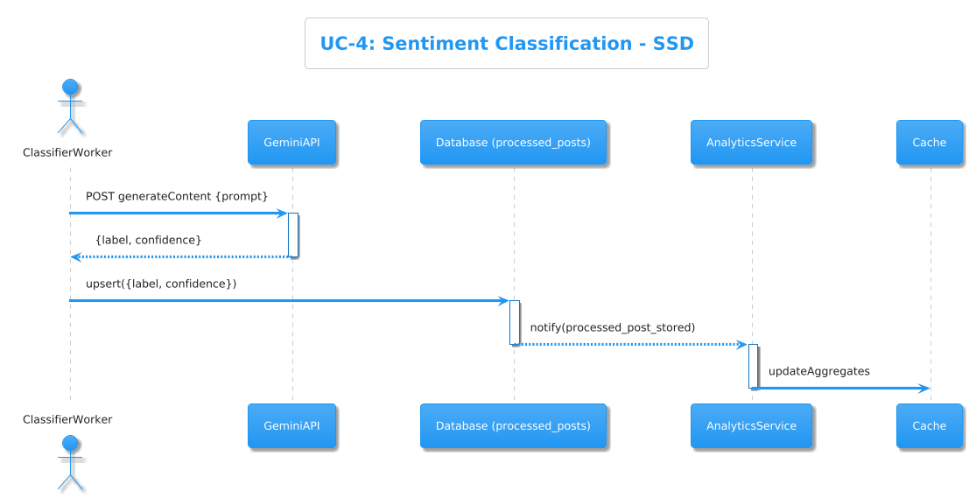
Figure 24 System Sequence 04
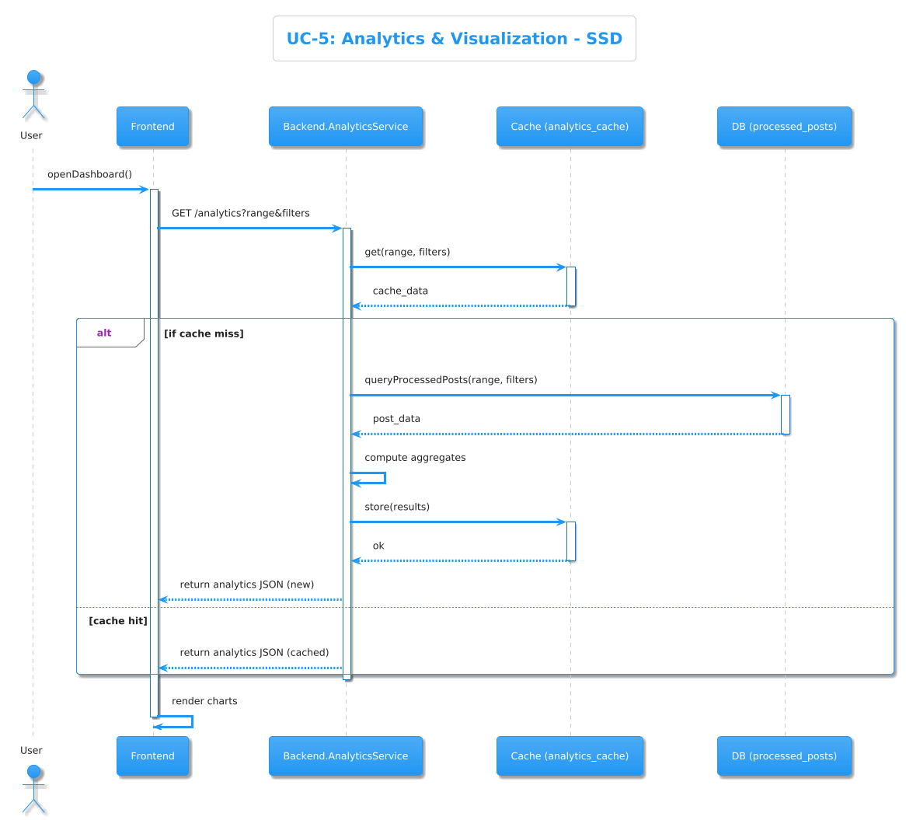
Figure 25 System Sequence 05
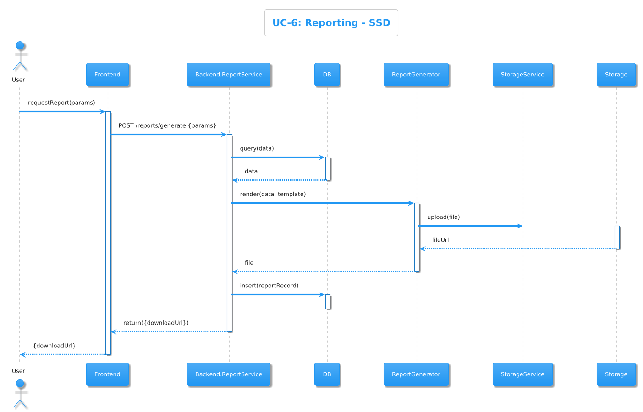
Figure 26 System Sequence 06
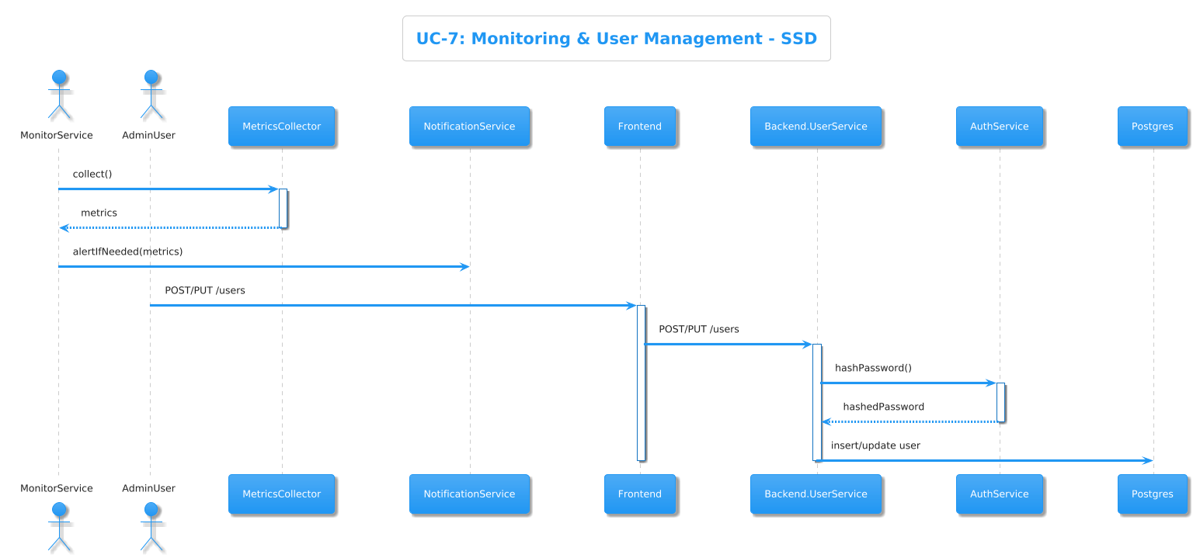
Figure 27 System Sequence 07

State Transition Diagrams:
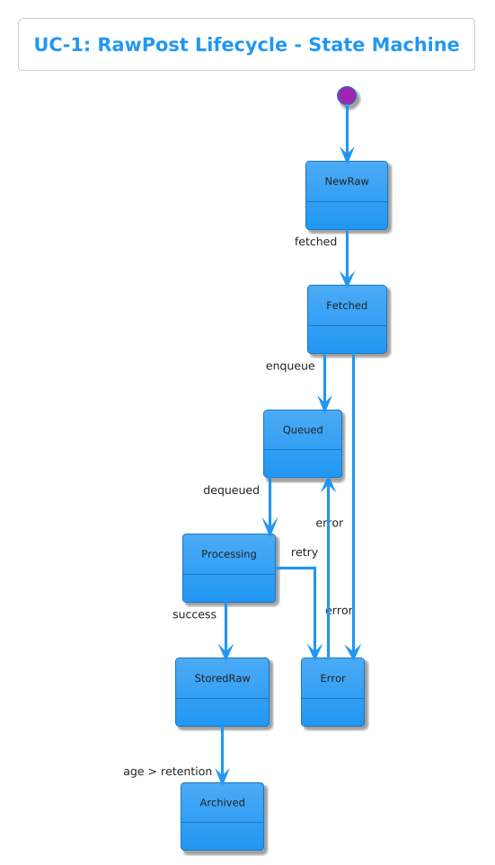
Figure 28 State Transition 01

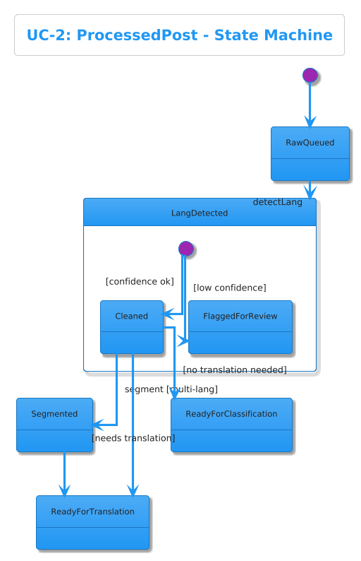
Figure 29 State Transition 02
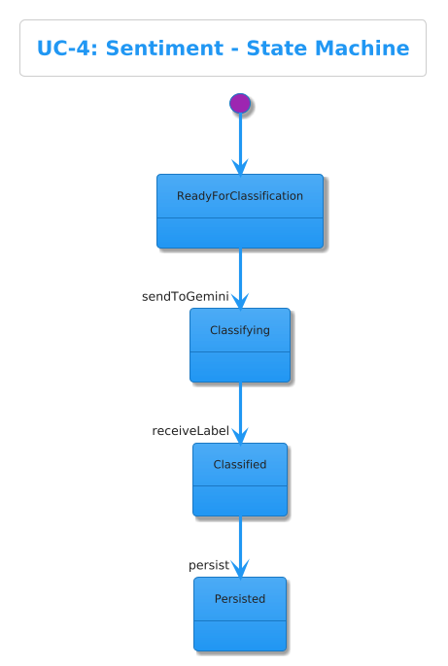
Figure 30 State Transition 04
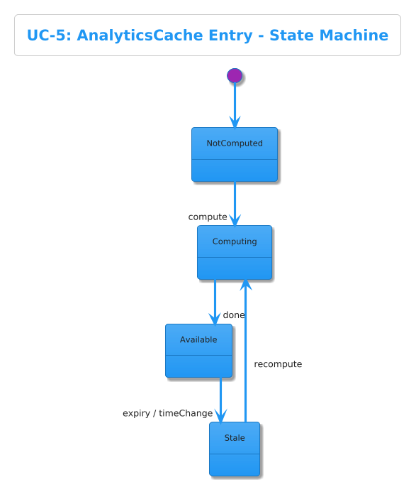
Figure 31 State Transition 05
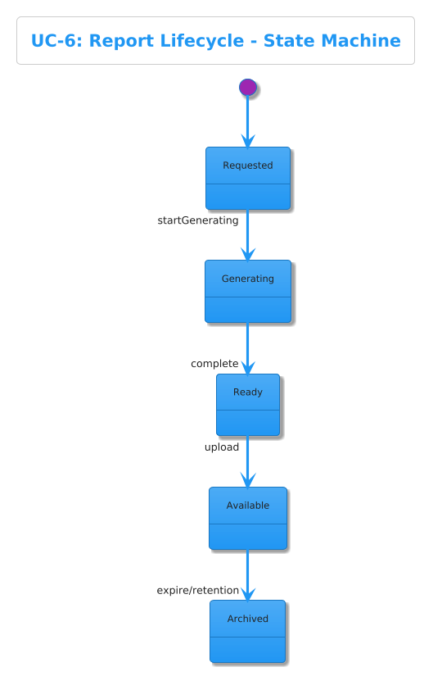
Figure 32 State Transition 06
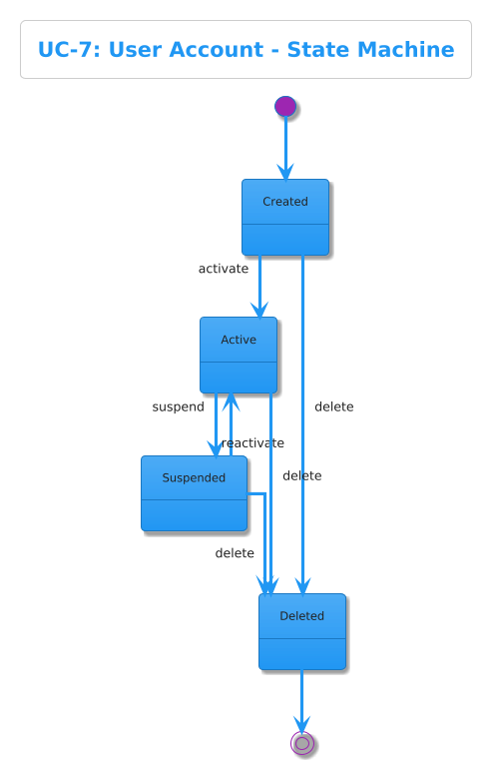
Figure 33 State Transition 07

Data Design
This document outlines the schema design for all database technologies (PostgreSQL, MongoDB, and Redis) used in the PakSentiment Data Gateway framework.

PostgreSQL Schema (Relational Data & Identity)

UserEntity (in users)
Description: Core user identity and subscription management table.
Attribute | Type | Description
id | Integer | Primary key, auto-incremented.
full_name | Varchar(100) | Full name of the user.
email | Varchar | Unique email address.
password_hash | Varchar | Optional. Encrypted password hash (null for OAuth users).
is_active | Boolean | Account status (default: true).
role | Enum | Access role: ‘free’, ‘premium’, ‘admin’.
subscription_tier | Enum | Billing tier: ‘free’, ‘premium’, ‘super_premium’.
created_at | Timestamp | Account creation timestamp.
updated_at | Timestamp | Last user modification timestamp.

IdentityEntity (in identities)
Description: Maps third-party OAuth providers (Google, GitHub) to a registered user.
Attribute | Type | Description
id | Integer | Primary key.
provider | Varchar(50) | OAuth provider name (e.g., ‘google’, ‘github’, ‘local’).
provider_id | Varchar | Unique identifier returned by the third-party provider.
user_id | Integer | Foreign key linking to the users table.
created_at | Timestamp | Identity linking timestamp.
updated_at | Timestamp | Last update timestamp.

ApiKeyEntity (in api_keys)
Description: Stores programmatic access tokens for users to consume the raw data gateway.
Attribute | Type | Description
id | Integer | Primary key.
user_id | Integer | Foreign key linking back to the users table.
api_key | Varchar(255) | The generated securely-hashed programmatic API key block.
created_at | Timestamp | Key generation date.
expires_at | Timestamp | Optional. Time at which the key is no longer valid.

UserActivityEntity (in user_activities)
Description: Audit log tracking distinct actions performed by human operators in the system.
Attribute | Type | Description
id | Integer | Primary key.
user_id | Integer | Foreign key linking back to the users table.
action | Varchar(50) | Constrained action string (e.g., ‘LOGIN’, ‘SEARCH_REDDIT’).
details | JSON | Optional. Specific query parameters, footprints, or summaries detailing the context.
created_at | Timestamp | Timestamp indicating when the activity transpired.

UserPreferenceEntity (in user_preferences)
Description: Explicit user UI settings and default dashboard parameters.
Attribute | Type | Description
id | Integer | Primary key.
user_id | Integer | Foreign key explicitly linking back to the human user.
theme | Varchar(20) | UI color layout string constraint (e.g., ‘light’/‘dark’).
default_platform | Varchar(50) | Optional. The primary engine they search using (e.g., ‘Web’).
default_language | Varchar(10) | Optional. Primary dashboard translation language string.
items_per_page | Integer | Intrinsic pagination ceiling metric (default: 20).

SystemConfigEntity (in system_configs)
Description: Universal system-wide environment variables stored permanently in the SQL database.
Attribute | Type | Description
id | Integer | Primary key.
config_key | Varchar(100) | Unique string-key delineator denoting a toggle configuration block.
config_value | Text | The corresponding variable to the associated system toggle key.
created_at | Timestamp | When the configuration flag was born.
updated_at | Timestamp | When the system configuration flag was last mutated.

MongoDB Schema (NoSQL Document & Log Stores)

ScrapedDocumentEntity (in scraped_documents)
Description: Stores the generic, immutable data retrieved from any source API alongside its processed sentiment analysis and chunk metadata. Replaces the legacy raw_posts and processed_posts separation.
Attribute | Type | Description
_id | ObjectId | Unique identifier for the document.
jobId | String | Optional. The identifier for an associated asynchronous crawl/scrape job.
url | String | The literal URL or unique URI of the fetched document.
domain | String | The root domain or author identifier (e.g., “twitter.com”, “medium.com”).
sourceEngine | String | The underlying engine used for extraction (e.g., ‘colly’, ‘scrapling’, ‘reddit’, ‘twitter’, ‘youtube’).
contentType | String | The classification format of the data (e.g., ‘article’, ‘social_post’, ‘video’).
title | String | Optional. The headline or title of the scraped content.
cleanText | String | The standardized, deeply parsed raw text extracted from the document.
metadata | Object (JSON) | Any platform-specific metadata (e.g., hashtags, likes, retweets, subreddits).
sentiment | Object (JSON) | Optional. The complex AI sentiment block containing inference results.
sentiment.label | String | The classified mood constraint (e.g., ‘Positive’, ‘Negative’, ‘Neutral’).
sentiment.score | Number | The confidence baseline score float (0.0 to 1.0).
sentiment.summary | String | A concise 3-4 sentence AI-generated snapshot of the document’s core context.
sentiment.analyzedAt | Date | Internal system timestamp indicating when the LLM executed the evaluation.
createdAt | Date | Auto-generated timestamp reflecting when the document was initially crawled.
updatedAt | Date | System timestamp recorded when the document is re-crawled or re-analyzed.

AnalysisSessionEntity (in analysis_sessions)
Description: Manages the relational mapping between a human user’s direct Smart Search query and the massive list of dynamically aggregated scraped_documents.
Attribute | Type | Description
_id | ObjectId | Primary key and unique identifier for the session document.
sessionId | String (UUID) | A cryptographically unique UUID tracking the distinct web application search event.
userId | Number | Foreign Key linking back to the distinct human (Maps to PostgreSQL User ID).
query | String | The literal web crawler search query typed by the user (e.g., “Go vs Java”).
source | String | The target search vector (e.g., ‘web_search’, ‘twitter_search’, ‘reddit_search’).
postIds | Array [String] | An array of stringified _id references mapping directly to documents stored inside scraped_documents.
createdAt | Date | System timestamp accurately indicating when the original Smart Search was triggered by the user.

CrawlJobEntity (in crawl_jobs)
Description: Tracks the execution status and telemetry for asynchronous, multi-page deep crawl jobs primarily executed by the Go Colly sidecar.
Attribute | Type | Description
_id | ObjectId | Primary MongoDB generated key.
sessionId | String (UUID) | The relational UUID tying the job map block back to a specific analysis_session.
url | String | Seed URL or string query metric initiated as the starting point.
status | String | Execution state machine status constraint: ‘pending’, ‘running’, ‘completed’, ‘failed’.
engine | String | Origin scraping engine footprint: ‘colly’, ‘scrapling’.
pagesScraped | Number | Real-time accumulator showing how wide the crawler reached inside the domain block.
results | Array [Object] | Deep hierarchical execution tracking array metric housing exact sub-page routing information.
createdAt | Date | Job invocation timestamp.
completedAt | Date | Job shutdown timestamp mapping to state machine completion or failure bounds.

AnalyticsCacheEntity (in analytics_cache)
Description: Stores pre-calculated, aggregated time-series metric blocks to reduce aggregate runtime computation overhead during intense Dashboard loads.
Attribute | Type | Description
_id | ObjectId | Primary key constraint tag.
date | Date | The daily baseline marker associated with this bucket block metric cluster.
totalPosts | Number | Accrued total summation of analyzed documents for this daily slice logic block.
positive | Number | Integer counter indexing entirely Positive categorized results.
negative | Number | Integer counter indexing entirely Negative categorized results.
neutral | Number | Integer counter indexing entirely Neutral categorized results.
topKeywords | Array [String] | An array constraint mapping textual keyword metric evaluations isolated for string map rendering on charts.
generatedAt | Date | Reflected computation execution limit block describing precise caching completion metrics.

SystemLogEntity (in system_logs)
Description: Persistent structured log routing destination mapping out non-destructive error handling architectures.
Attribute | Type | Description
_id | ObjectId | Main primary key.
level | String | Standard logging tier representation (e.g., ‘info’, ‘warn’, ‘error’).
message | String | Complete string metric defining internal logging exception parameters natively.
timestamp | Date | Execution time tracking variables defining precise metric constraint footprints.
component | String | Architectural constraint delineator tracking error origin maps (e.g., ‘NestJS’, ‘Sidecar’).

Redis Schema (Cache Maps & Queues)
Description: Standardized low-latency, ephemeral in-memory storage structure. Keys strictly use standard Redis namespaces delimited by a single colon :.
Keystore Paradigm Namespace | Structure Type | Description / Expiration Rules
scrape:page:[MD5_HASH_OF_URL] | String (HTML text) | A fully cached, unparsed HTML copy of a crawled page preventing duplicate scrapes of the same exact target domain URI over the system session. Expired dynamically based on Go configuration parameters.
scrape:lock:[MD5_HASH_OF_URL] | String | Atomic mutual exclusion lock string representation dictating hard multi-thread barriers during concurrent parallel Colly execution blocks, persisting entirely for exactly 5 minutes explicitly mapped in Golang code.
scrape:stats:hits | Integer Counter | An incrementing integer tracking raw metrics for successfully resolved HTML Redis deduplications.
scrape:stats:misses | Integer Counter | An incrementing integer tracking raw metrics for newly routed external HTTP requests generated by misses on the cache node hierarchy.

Data Dictionary
This dictionary centralizes key data fields used across the system.
Attribute | Description | Data Type | Format / Allowed Values
platform | Platform source identifier | String | "twitter", "reddit", "youtube"
content | Original text from post | String | UTF-8 text
clean_text | Cleaned version of the text | String | UTF-8 text
language | Detected language | String | "en", "ur", "ps", "sd", etc.
sentiment | Sentiment classification | String | "positive", "negative", "neutral"
confidence | Model confidence score | Number | 0.0–1.0
timestamp | Original post date | Date | ISO 8601
processed_at | System processing timestamp | Date | ISO 8601
config_key | System setting name | String | "enable_translation", "max_posts_per_request"
Data Validation Rules:
- Text fields intended for processing must be sanitized to remove scripts, HTML, and other non-text artifacts.
- Sentiment labels must conform to the predefined set ("positive", "negative", "neutral").
- Confidence scores must be validated to be within the range [0.0, 1.0].
- Timestamps must adhere to the ISO 8601 standard.
- Foreign key constraints in PostgreSQL are enforced at the database level.

Human Interface Design
Describe the functionality of the system from the user’s perspective. Explain how the user will be able to use our system to complete all the expected features and the feedback information that will be displayed for the user.

Screen Images

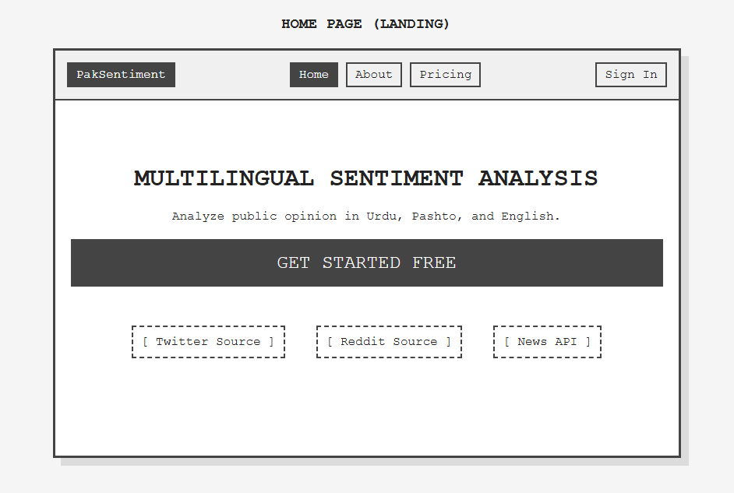
Figure 34 Home Page HID

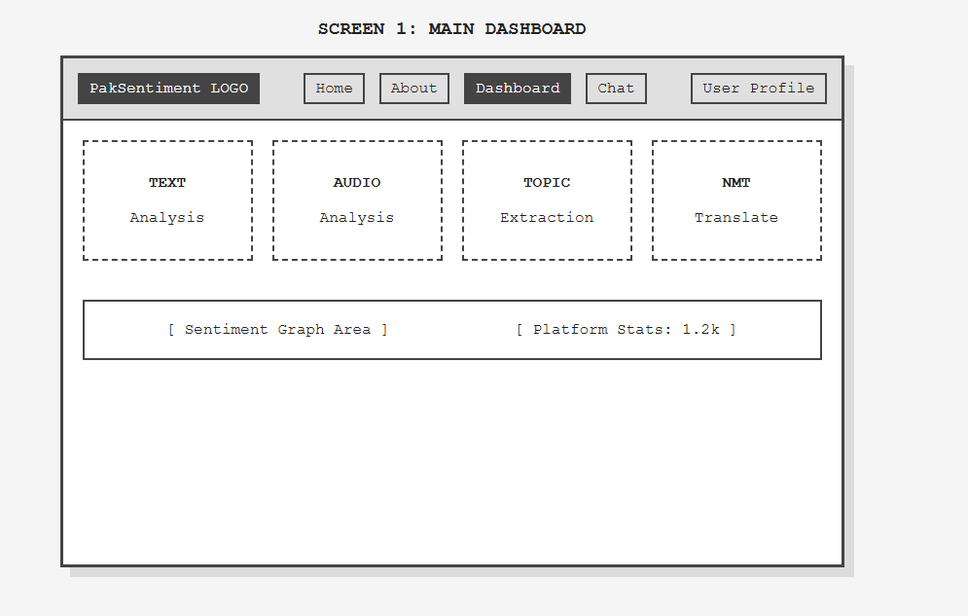
Figure 35 Main Dashboard HID
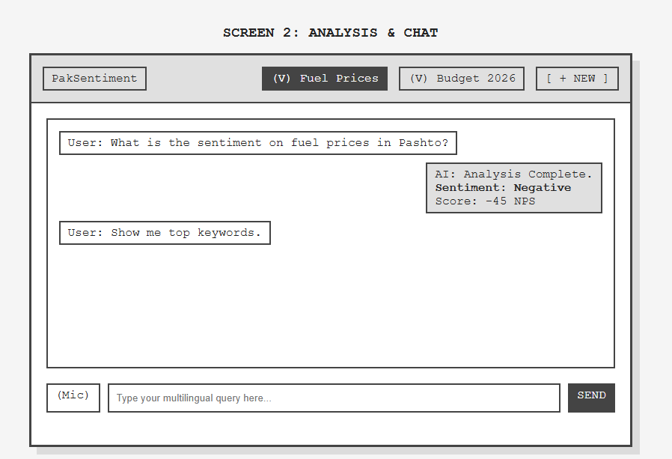
Figure 36 Analysis and chart HID

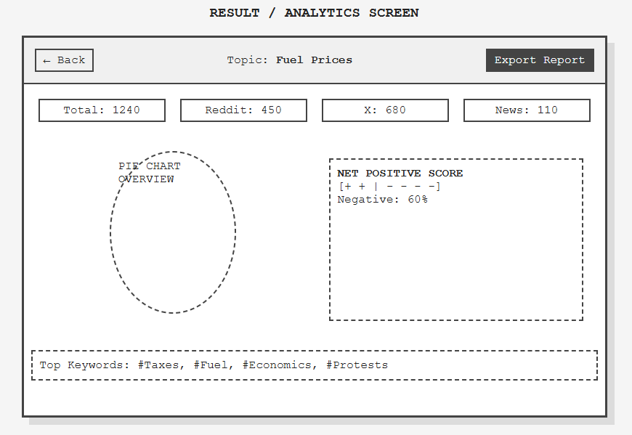
Figure 37 Result Screen HID
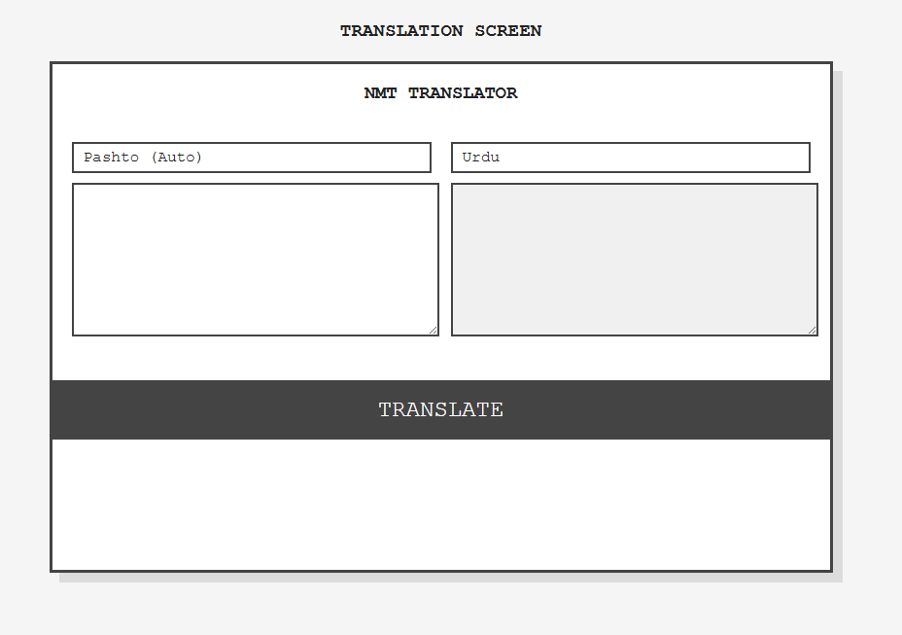
Figure 38 Translation Screen HID
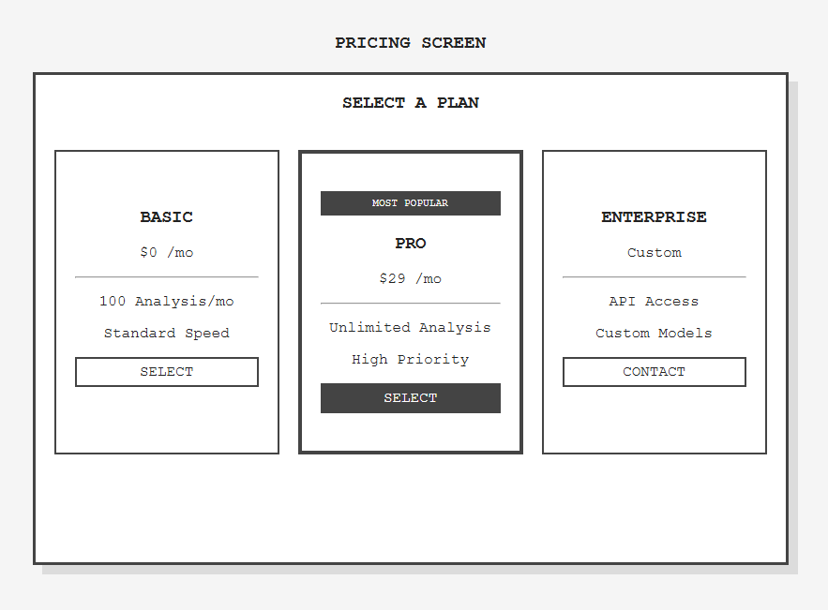
Figure 39 Pricing Screen HID
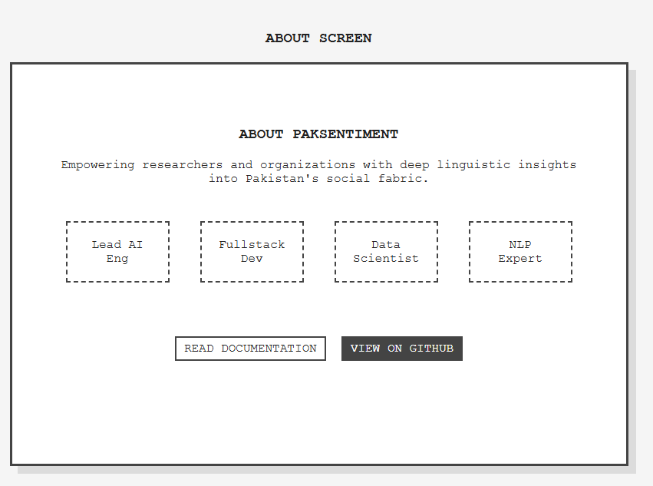
Figure 40 About Screen HID

Screen Objects and Actions

Home Page
Object: Persistent Navigation Bar (Nav Bar)
Objects: PakSentiment Logo, Home, About, Dashboard, Chat, Pricing.
Action: User clicks on any navigation link.
Feedback: The system navigates to the corresponding page. The clicked link becomes highlighted to indicate the active page.
Object: Persistent Authentication Buttons
Objects: Sign In Button, Sign Up Button.
Action: User clicks Sign In or Sign Up.
Feedback: The system displays the Login or Registration page, prompting the user for their credentials.
Object: Hero Section CTA
Objects: “Get Started” Button.
Action: User clicks the button.
Feedback: Redirects the user to the Registration page or Dashboard if already logged in.

Login Screen
Object: Credential Input Fields
Objects: Email field, Password field, “Remember Me” checkbox.
Action: User enters credentials and clicks “SIGN IN”.
Feedback: Sign In (Algorithm 8): If successful, user is redirected to the Main Dashboard. If invalid, a red text error message (“Invalid credentials”) is displayed.
Object: Password Visibility Toggle
Objects: Eye icon in Password field.
Action: User clicks the icon.
Feedback: Toggles the password field text between masked (dots) and visible characters.
Object: Help Links
Objects: “Forgot Password?” link, “Sign up” link.
Action: User clicks to navigate.
Feedback: Redirects to the Forgot Password or Registration screen respectively.

Registration Screen
Object: Account Details Form
Objects: Full Name, Email, Password, Confirm Password fields.
Action: User fills details and clicks “CREATE ACCOUNT”.
Feedback: System validates input; if successful, creates account and redirects to Login or Dashboard.
Object: Terms Agreement
Objects: “Terms of Service” checkbox.
Action: User clicks to check.
Feedback: Enables the “CREATE ACCOUNT” button.

Main Dashboard
Object: Quick Analysis Tools
Objects: Text Analysis, Audio Analysis, Topic Creation, Translation tiles.
Action: User clicks a tool tile.
Feedback: Redirects the user to the relevant detailed analysis screen (e.g., Chat Screen or Translation form).
Object: Analytics Mini-Charts
Objects: Sentiment Distribution Pie Chart, Recent Activity Line Chart.
Action: Read-only (Algorithm 4).
Feedback: Reflects the latest cached state of analyzed data and system health.
Object: Search & Analysis Bar
Objects: Input field, “Start Analysis” button.
Action: User enters a topic/URL and clicks button.
Feedback: Triggers ingestion (Algorithms 1, 3). Shows “Processing…” loader.

Result / Analytics Screen
Object: Platform Metric Cards
Objects: Total Posts, Reddit Count, Twitter Count, News Count.
Feedback: Read-only numerical summaries of the query data.
Object: Sentiment Visualization
Objects: Overall Sentiment Bar Chart, Net Positive Score gauge.
Feedback: Provides visual breakdown of sentiment percentages derived from analytics_cache.
Object: Action Tools
Objects: “Export Report” Button, “Deep Dive” Button.
Action: User clicks “Export Report”.
Feedback: Triggers Report Generation (Algorithm 6) and initiates PDF/CSV download.

Analysis and Chat Screen
Object: Conversation Interface
Objects: Chat History bubbles, Text Input Box, “Send” Button.
Action: User enters text and clicks “Send”.
Feedback: Text is processed (Algorithm 1) and classified (Algorithm 3). Sentiment results appear in a new chat bubble.
Object: Voice Input Tool
Objects: Microphone “Voice” Icon.
Action: User clicks and speaks.
Feedback: Groq API (Whisper v3) converts speech to text and submits it to the pipeline.

Translation Screen
Object: Language Selector
Objects: Source Language (Pashto/Urdu/English) dropdown, Target Language dropdown.
Action: User selects languages.
Feedback: Configures the NMT engine for the specific pair.
Object: Translation Box
Objects: Source Text input, “Translate” Button, Target Text output.
Action: User clicks “Translate”.
Feedback: Displays translated text using the local NMT model.

Forgot Password Screen
Object: Email Recovery
Objects: Email input field, “Send Reset Link” button.
Action: User enters email and clicks button.
Feedback: System sends a recovery email and displays a success notification message.

Pricing Screen
Object: Subscription Tiers
Objects: Basic, Pro, Enterprise cards, “Select Plan” buttons.
Action: User clicks a plan button.
Feedback: Redirects to the payment gateway or confirms plan selection.

About Screen
Object: Team & Project Info
Objects: Vision statement, Developer profiles, Documentation links.
Action: User clicks documentation links.
Feedback: Opens relevant technical docs or GitHub repository.

Implementation
This chapter will discuss implementation details of the project. You will not put your source code here, however, are required to write the core modules functionalities in pseudocode form (Following sections are required in this chapter).

Note: You are required to follow proper coding standard to write your source code. For guidelines, General Coding Standards & Guidelines are provided in Appendix D.

Algorithm

Table 4 Example of Algorithm

Algorithm 1 Text Preprocessing
Input: Raw text raw_text
Output: Cleaned text clean_text, detected language language_code
1: clean_text ← raw_text.lower()
2: Remove URLs, mentions, hashtags from clean_text
3: Remove emojis, special symbols, and HTML tags
4: Replace multiple spaces with single space
5: language_code ← detectLanguage(clean_text)
6: if length(clean_text) < MIN_LENGTH then
7: return (NULL, language_code)
8: end if
9: return (clean_text, language_code)

Algorithm 2 Translate to Urdu
Input: clean_text, language_code
Output: Boolean value
1: if language_code == "ur" then
2: return clean_text
3: end if
4: prompt ← "Translate the following text into Urdu:\n" + clean_text
5: model ← loadLLM("llama-3.2")
6: response ← model.generate(prompt)
7: translated_text ← extractText(response)
8: return translated_text

Algorithm 3 Sentiment Classification
Input: Text (raw or translated)
Output: sentiment_label
1: prompt ← """
Classify the sentiment of the following text as:
Positive, Negative, or Neutral.
Respond ONLY with one label.
Text: """ + text
2: request_body ← {
"contents": [{ "parts": [{ "text": prompt }] }]
}
3: response ← HTTP.POST(
"gemini-1.5-flash:generateContent",
request_body
)
4: sentiment_label ← extractLabel(response.text)
5: confidence_score ← estimateConfidence(response)
6: return (sentiment_label, confidence_score)
Algorithm 4 Analytics Aggregation
Input: List of processed posts posts[]
Output: Analytics summary object
1: Group posts by date
2: For each date group:
3: count_positive ← count(sentiment == positive)
4: count_negative ← count(sentiment == negative)
5: count_neutral ← count(sentiment == neutral)
6: percentages ← computePercentage(counts)
7: keywords ← extractTopKeywords(posts)
8: top_posts ← selectHighConfidence(posts)
9: Save results to analytics_cache
10: return analytics_summary
Algorithm 5 Social Media Post Ingestion
Input: Platform name, query parameters
Output: List of raw posts
1: Authenticate with platform API
2: request ← buildRequest(platform, query_parameters)
3: response ← callAPI(request)
4: posts ← parseResponse(response)
5: For each post in posts:
6: Validate required fields
7: Insert post into raw_posts
8: Handle rate limits using exponential backoff
9: return posts
Algorithm 6 Report Generation
Input: Date range, filters
Output: Report file (PDF or CSV)
1: posts ← queryProcessedPosts(filters, date_range)
2: formatted ← formatDataAsTable(posts)
3: charts ← generateCharts(posts)
4: report ← renderReportTemplate(formatted, charts)
5: Save report to temporary storage
6: return report_file
Algorithm 7 Error Handling
Input: Error object error, component name
Output: None
1: severity ← classifyError(error)
2: Log error message, stack trace, component to system_logs
3: if severity == transient then
4: Retry operation with exponentialBackoff()
5: else if severity == critical then
6: Notify system and halt component
7: end if
Algorithm 8: Backend User Authentication
Input: email, password
Output: access_token or AuthenticationError
1: user ← UserRepository.findByEmail(email)
2: if user == NULL then
3: return AuthenticationError("User not found")
4: end if
5: isValid ← bcrypt.compare(password, user.hashed_password)
6: if isValid == false then
7: return AuthenticationError("Invalid credentials")
8: end if
9: payload ← { "userId": user.id, "email": user.email }
10: access_token ← JWT.sign(payload, SECRET_KEY, expiry=24h)
11: return access_token
Algorithm 8.1: JWTMiddleware
Input: request, response, next()
Output: Request allowed or AccessDenied
1: token ← request.headers["authorization"]
2: if token == NULL then
3: return AccessDenied("Missing token")
4: end if
5: try:
6: decoded ← JWT.verify(token, SECRET_KEY)
7: catch VerificationFailed:
8: return AccessDenied("Invalid or expired token")
9: end try
10: request.user ← decoded
11: next()
Algorithm 9: CallDataSourceService
Input: endpoint, payload
Output: response_data
1: requestBody ← JSON.stringify(payload)
2: headers ← { "Content-Type": "application/json" }
3: try:
4: response ← HTTP.post(endpoint, requestBody, headers)
5: catch NetworkError:
6: return Error("Network failure")
7: end try
8: if response.status != 200 then
9: return Error("Failed at data source")
10: end if
11: return response.data
Algorithm 10: SaveToLocalStorage
Input: key, value
Output: None
1: jsonString ← JSON.stringify(value)
2: localStorage.setItem(key, jsonString)
3: return
Algorithm 11: Validate Login Form
Input: form_data {email, password}
Output: errors
1: errors ← {}
2: if form_data.email is empty then
3: errors.email ← "Email is required"
4: else if not matchRegex(form_data.email, EMAIL_REGEX) then
5: errors.email ← "Invalid email format"
6: end if
7: if form_data.password is empty then
8: errors.password ← "Password is required"
9: else if length(form_data.password) < 6 then
10: errors.password ← "Password must be at least 6 characters"
11: end if
12: return errors
Algorithm 12: Display Form Data
Input: form_data
Output: Rendered UI elements
1: fields ← Object.keys(form_data)
2: For each field in fields:
3: Create a visual label for field
4: Create a value element showing form_data[field]
5: Render all elements in a form summary component
6: return
Algorithm 13: useFetchAnalytics
Input: api_url
Output: object {data, loading, error}
1: Set loading ← true
2: Set data ← null
3: Set error ← null
4: try:
5: response ← fetch(api_url)
6: json ← response.json()
7: data ← json
8: catch e:
9: error ← e
10: end try
11: loading ← false
12: return {data, loading, error}
Algorithm 14: Call Backend API
Input: endpoint, method, body
Output: response_data or APIError
1: headers ← {"Content-Type": "application/json"}
2: if access_token exists then
3: headers["Authorization"] ← "Bearer " + access_token
4: end if
5: try:
6: response ← fetch(endpoint, {method, headers, body})
7: catch NetworkFailure:
8: return APIError("Connection failed")
9: end try
10: if response.status not in [200, 201] then
11: return APIError("Backend error")
12: end if
13: return response.json()
Algorithm 15: useFormState
Input: initial_values
Output: Object{values, handleChange, reset}
1: values ← initial_values
2: handleChange(field, new_value):
3: values[field] ← new_value
4: end handleChange
5: reset():
6: values ← initial_values
7: end reset
8: return {values, handleChange, reset}

External APIs/SDKs
Describe the third-party APIs/SDKs used in the project implementation in the following table.

Table 5 Details of APIs used in the project

Name of API and version | Description of API | Purpose of usage | List down the API endpoint/function/class in which it is used
Groq API (v1) | High-speed LLM-based inference engine. | AI assistant interaction and real-time sentiment extraction. | PakSentiment-data-gateway/services/sentiment_classifier.py → GroqSentimentClassifier
YouTube Data API (v3) | Official YouTube content and comment access API. | Scrapes videos, comments, and transcripts for video sentiment analysis. | PakSentiment-data-gateway/services/youtube_service.py → search_videos
Stripe API (Latest) | Secure online payment processing platform. | Manages user subscriptions, payment intents, and billing operations. | payments.service.ts → createPaymentIntent
Reddit API (v1) | Social media platform API for public discussions. | Fetches Reddit posts and comments to analyze community sentiment. | PakSentiment-scraper → RedditScraperClient
Twitter (X) API (v2) | Real-time social media data stream API. | Tracks trends, tweets, and public reactions for sentiment analysis. | PakSentiment-scraper → XScraperClient
Common Crawl API | Web archive search and retrieval platform. | Identifies historical web data for long-term trend analysis. | PakSentiment-data-gateway/services/commoncrawl_service.py → fetch_records
FastAPI (v0.100+) | High-performance Python API framework. | Provides scraping and sentiment analysis endpoints for backend orchestration. | PakSentiment-data-gateway/main.py → @app.get("/reddit/sentiment")
NestJS (v10+) | Enterprise-grade Node.js backend framework. | Acts as the main gateway handling authentication and business logic. | ai.service.ts → chat
Colly (v2.x) | Go-based high-speed web scraping library. | Scrapes static HTML content from news portals and websites. | crawler.go → HandleScrape
MongoDB Driver | Official NoSQL database interface. | Stores and manages raw scraped data and processed sentiment results. | mongo.go → mongo.Collection.InsertOne

User Interface

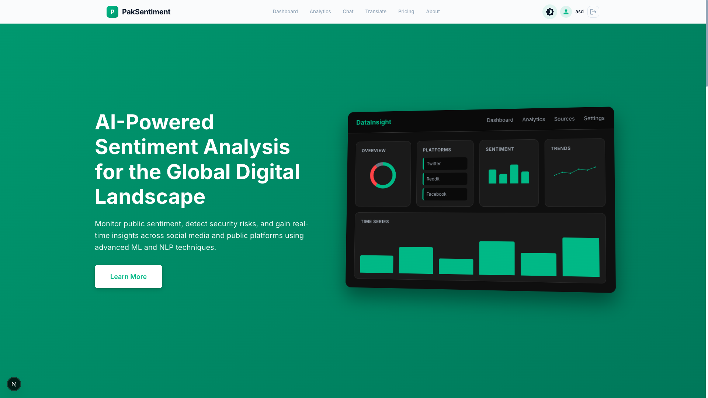

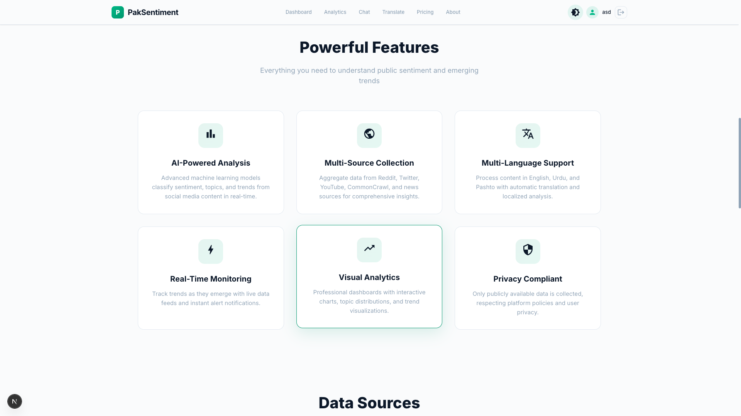

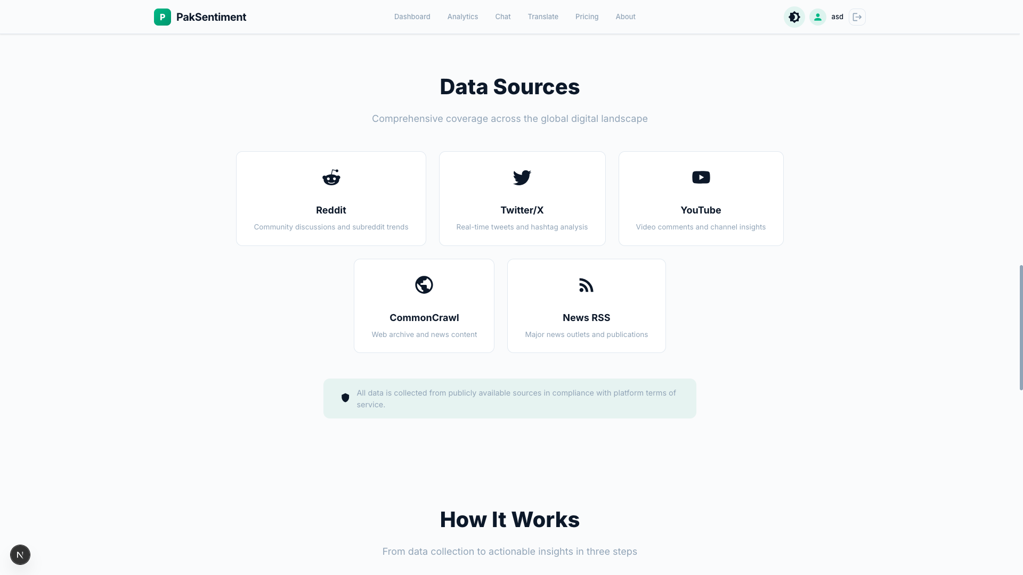

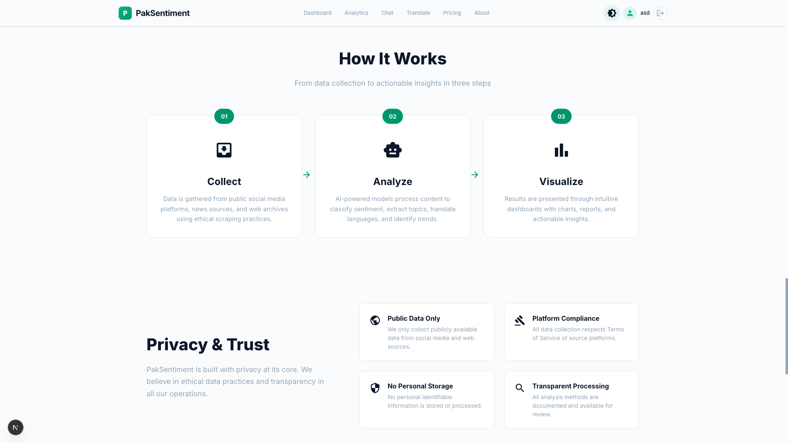

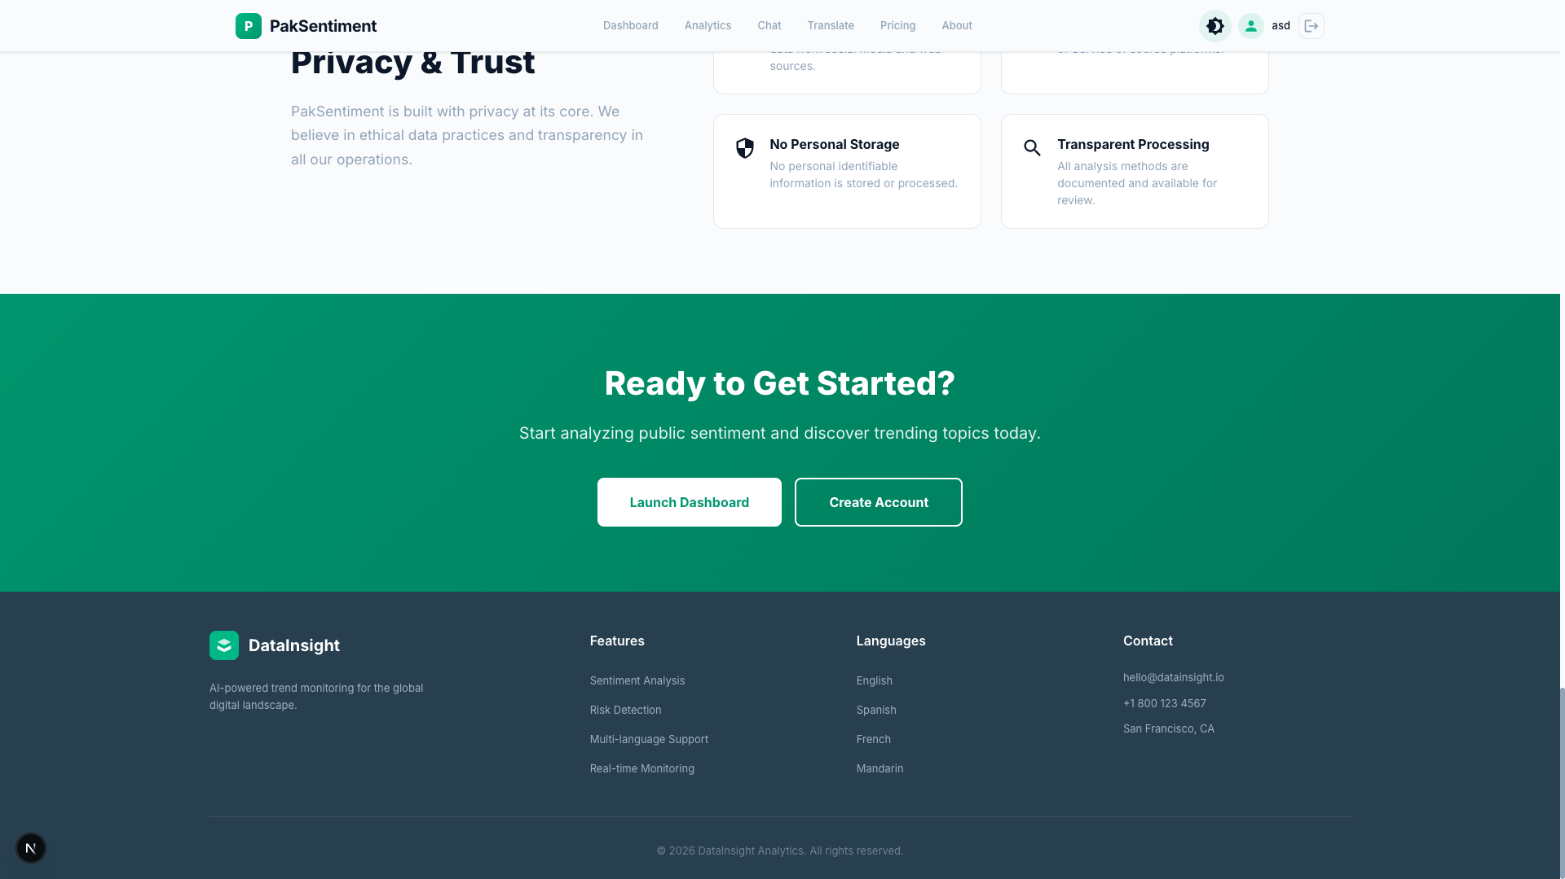

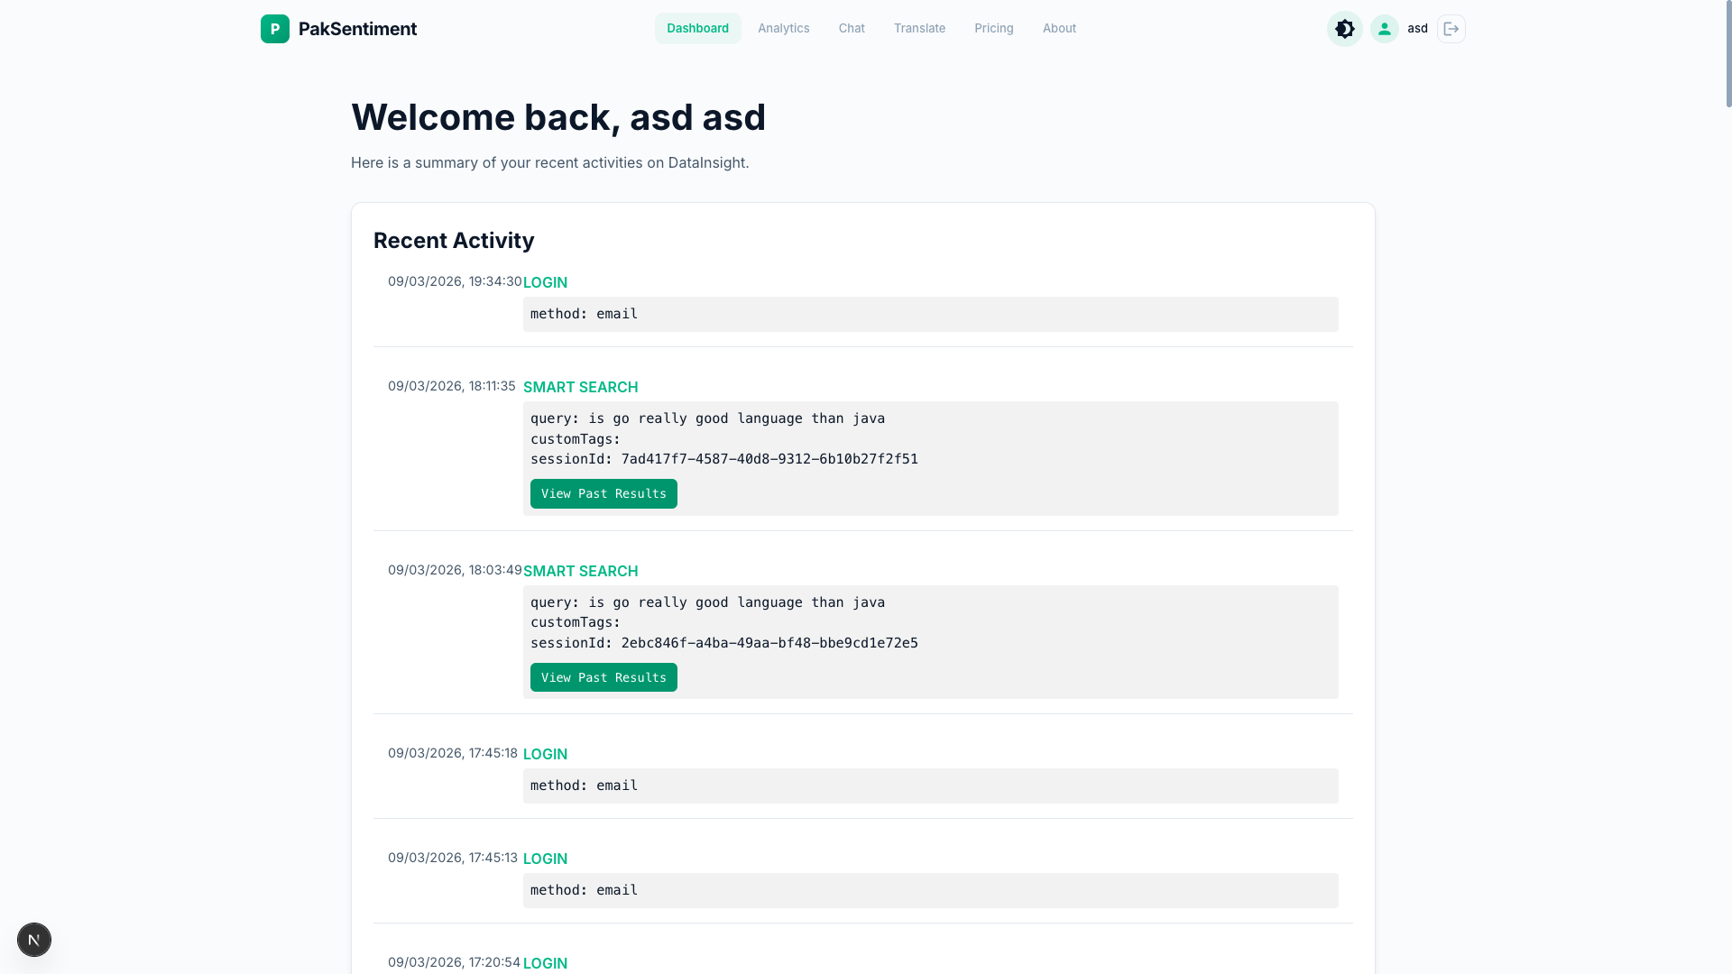

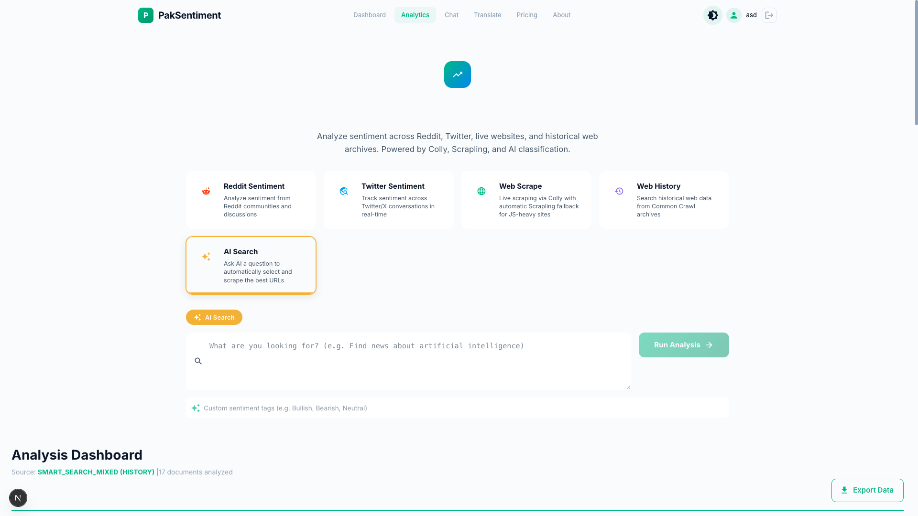

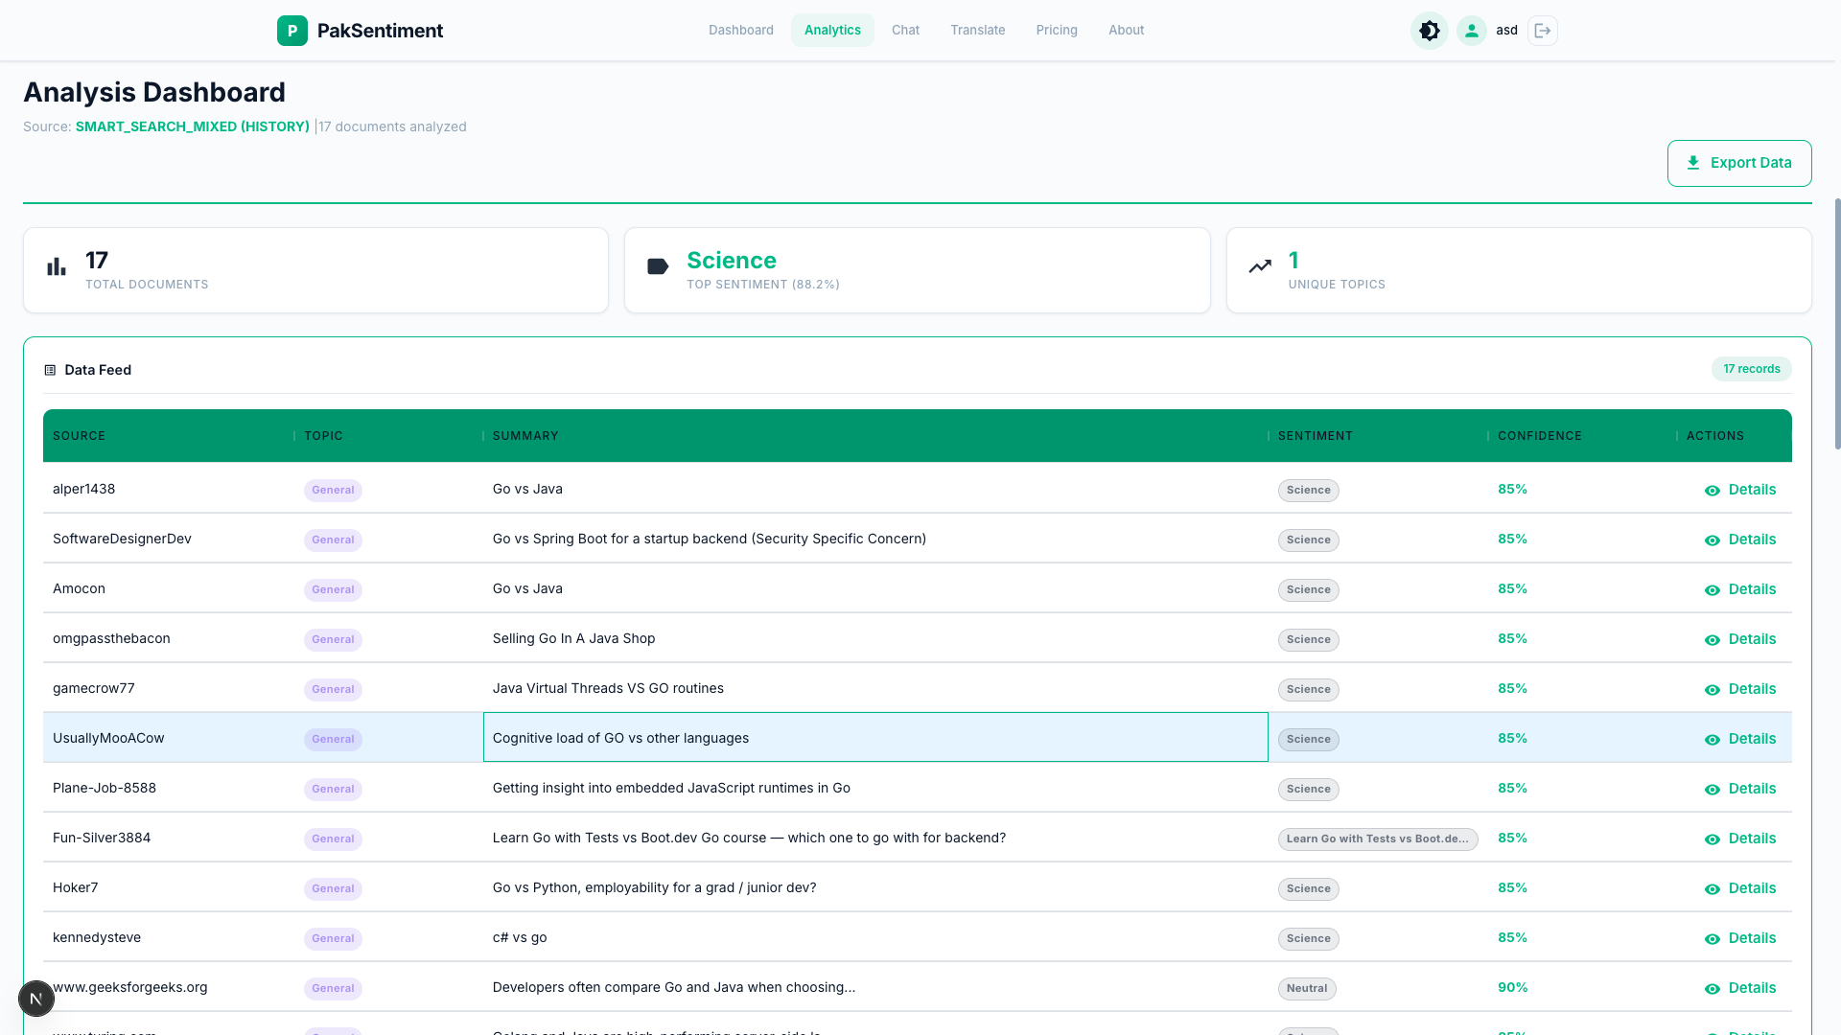

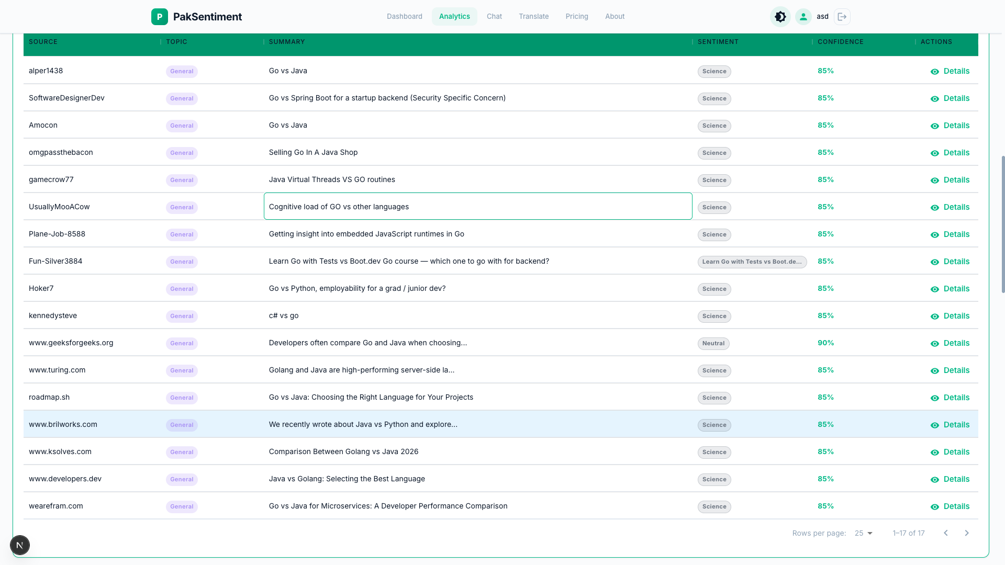

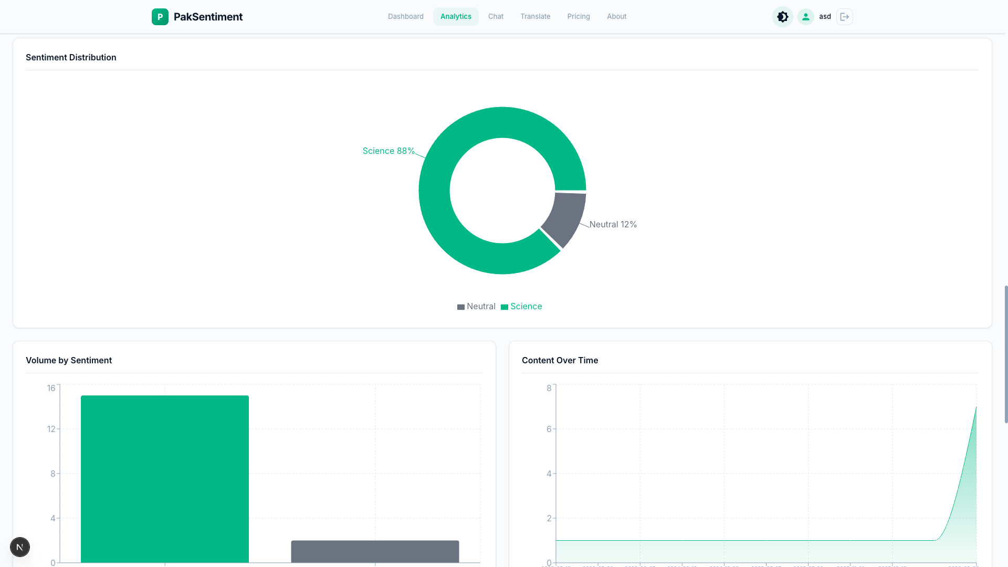

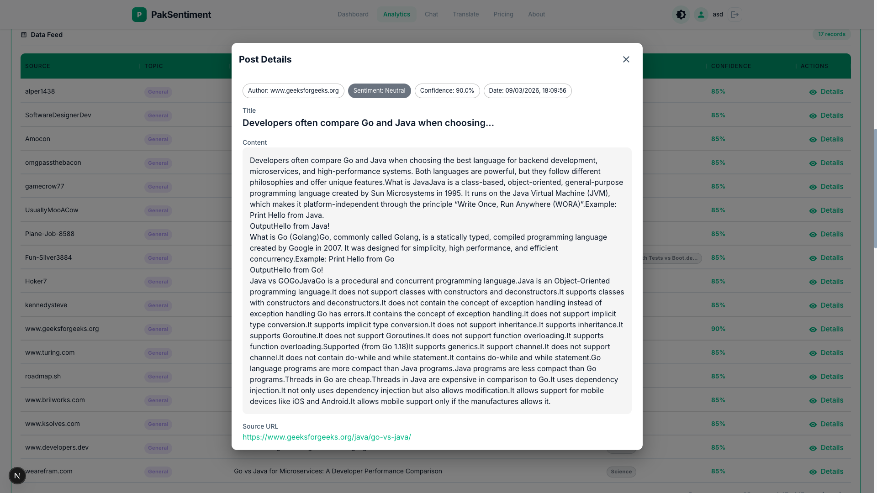

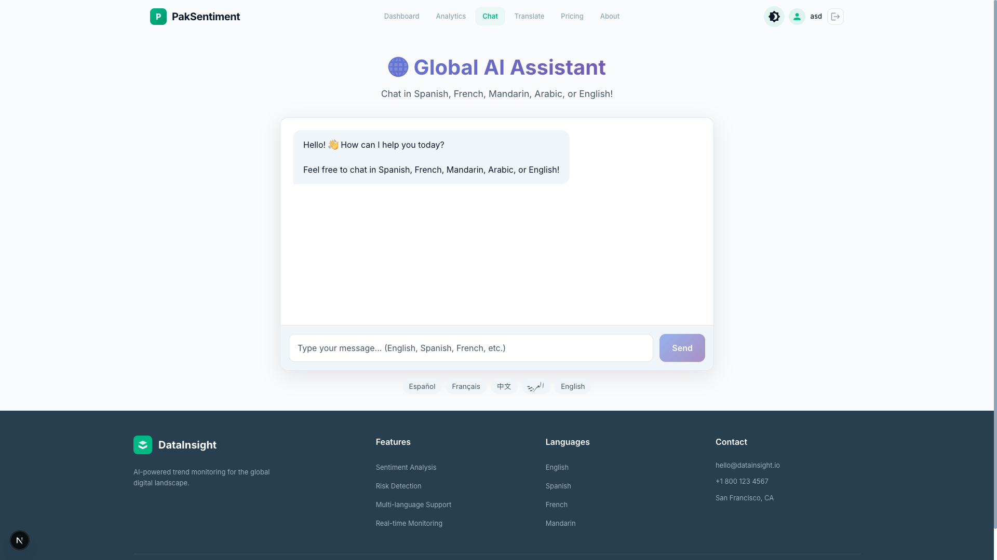

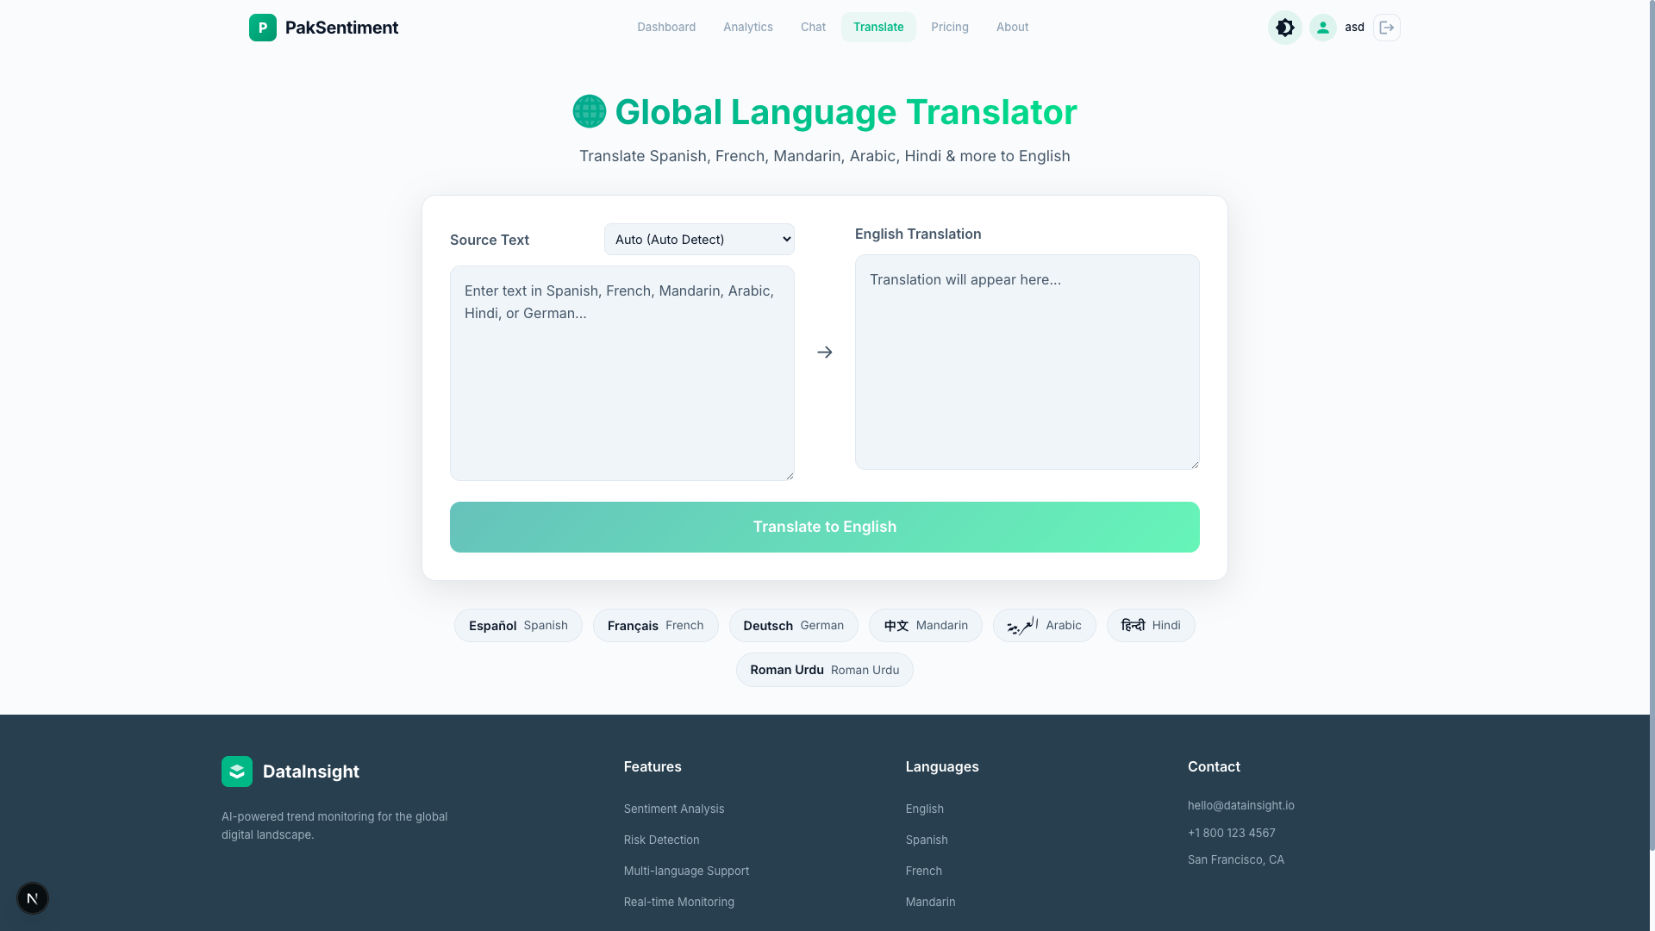

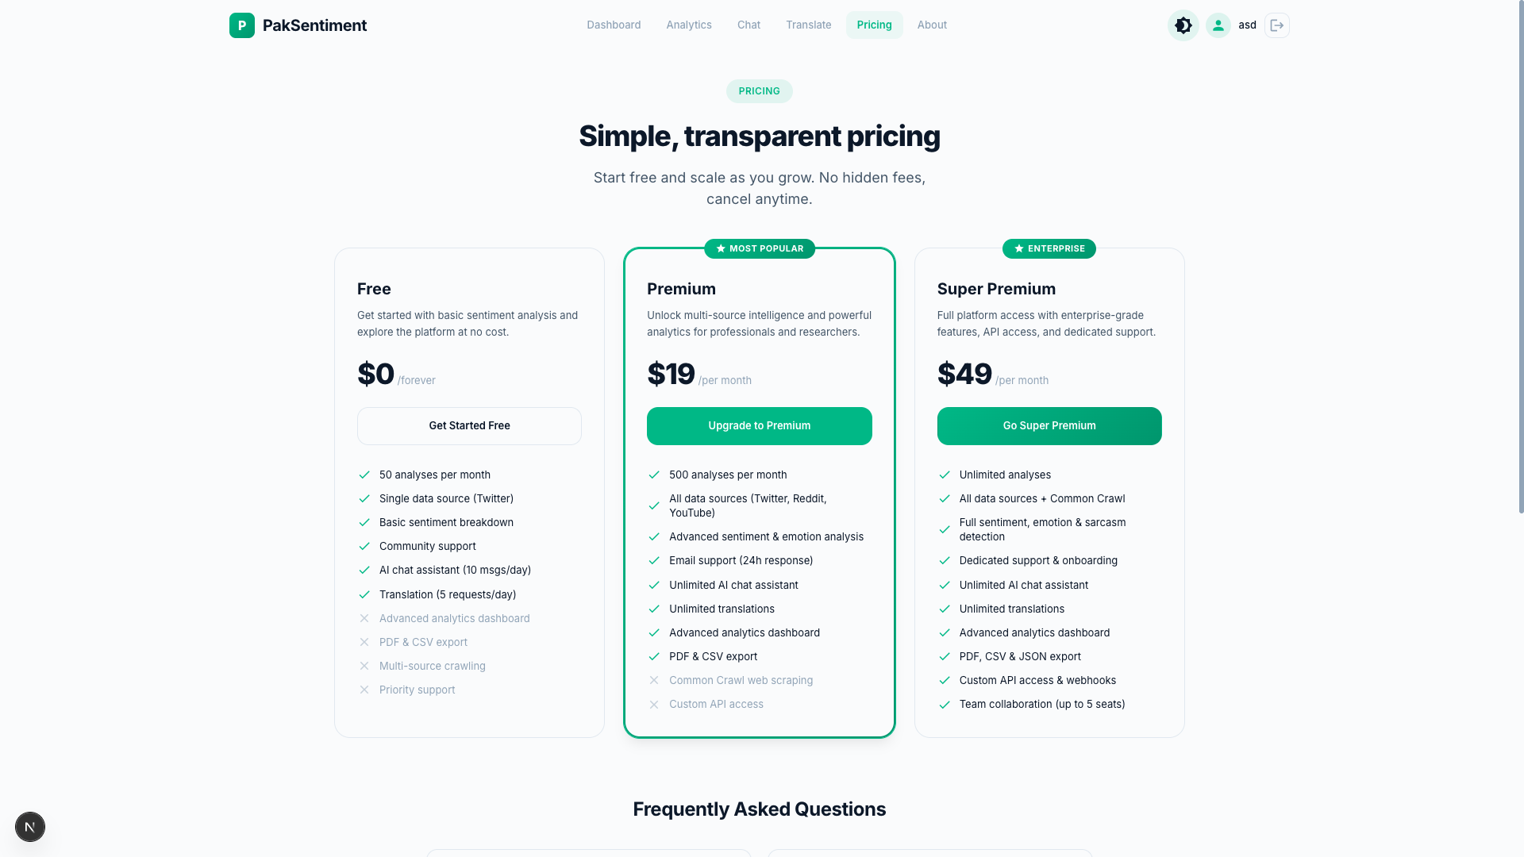

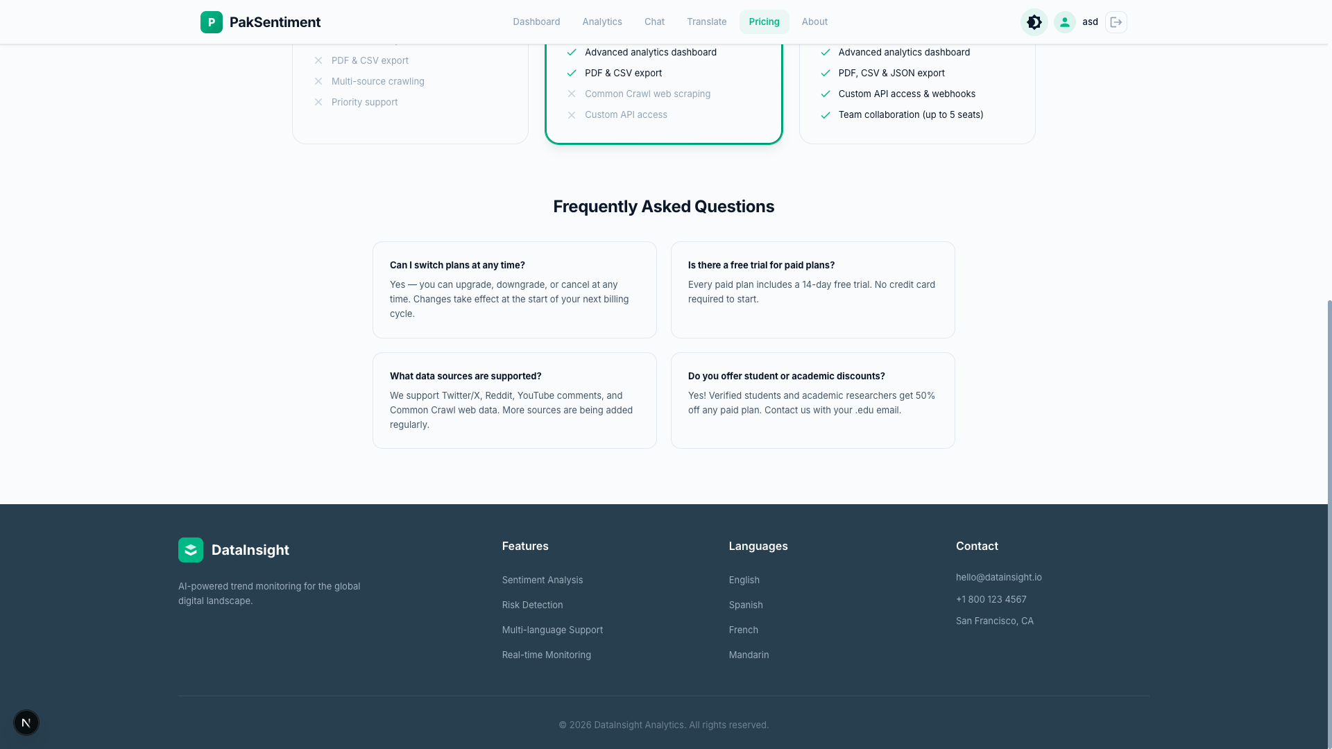

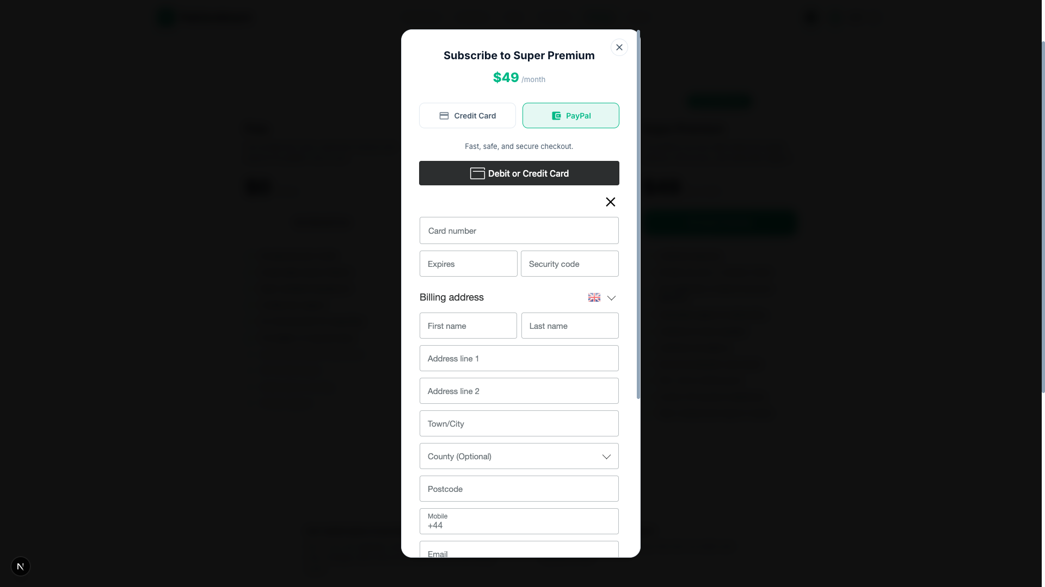

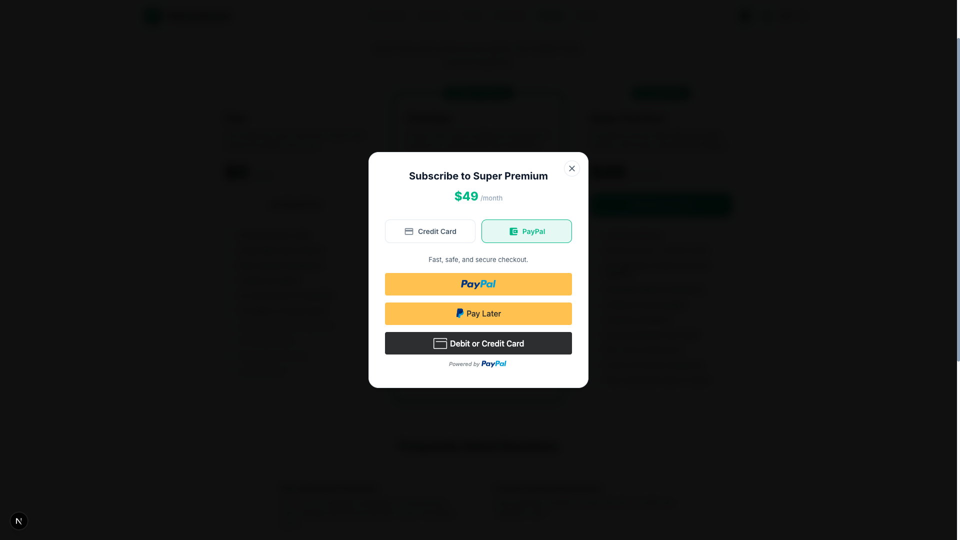

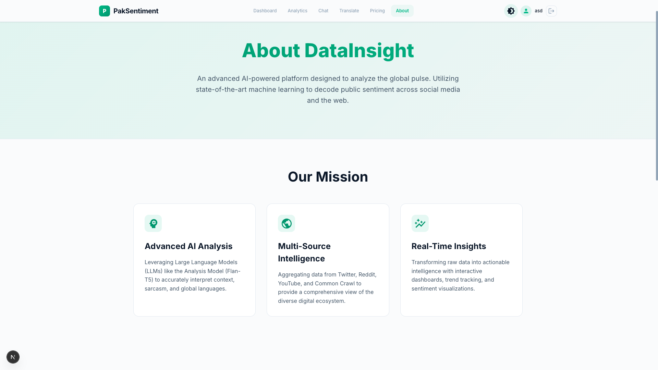

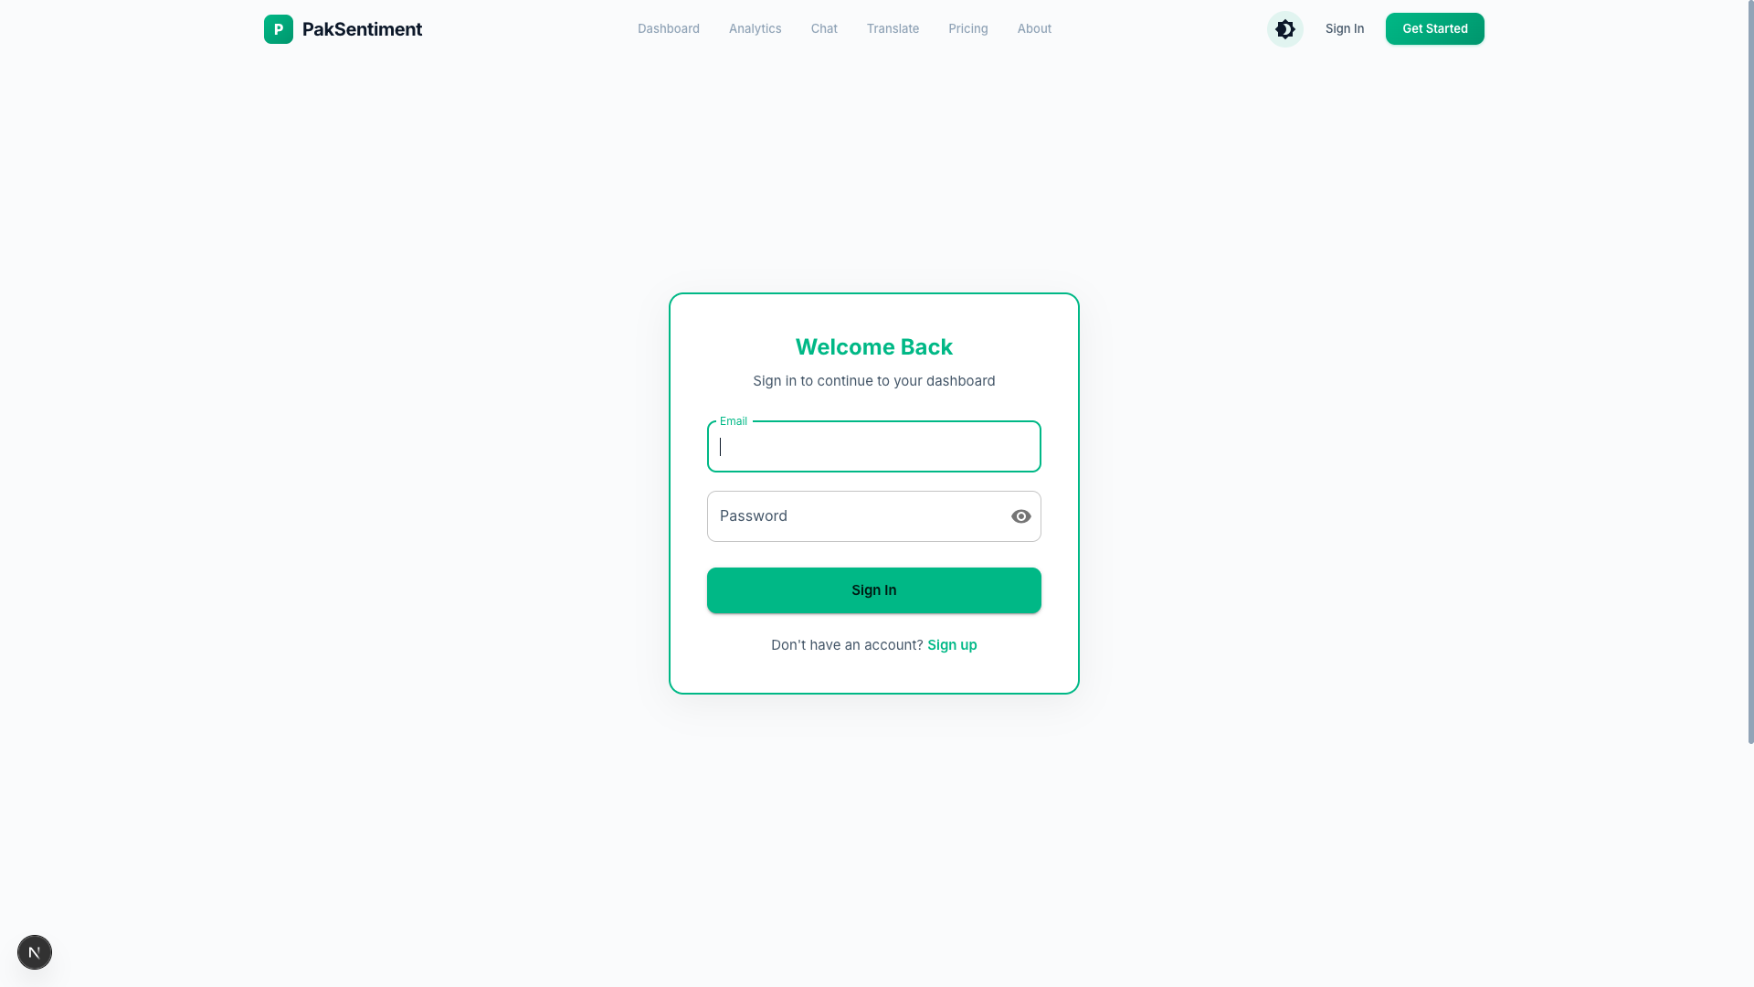

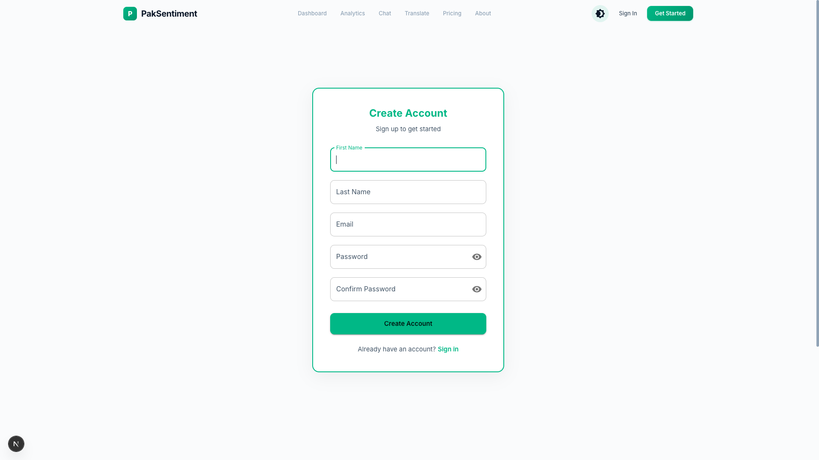

Deployment

Hosting and Infrastructure

Aspect | Details
Hosting Type | Self-hosted Linux Server (VPS)
Containerization | Docker Engine with Docker Compose
Architecture | Microservices (4 application services + 3 databases)
Orchestration | docker-compose.yml (version 3.9)
Network | Docker internal bridge network with isolated service-to-service communication
Data Persistence | Docker named volumes (pgdata, mongodata, redisdata)

Application Subsystems

Frontend — Next.js

Software | Version
Runtime | Node.js 20 (Alpine)
Framework | Next.js 15.5.6
UI Library | React 19.1.0
Language | TypeScript 5.x
Styling | SCSS Modules
Charting | Recharts
State Management | Zustand
Docker Base Image | node:20-alpine (multi-stage build)
Internal Port | 3001
Host Port | 5001

Backend API — NestJS
Software | Version
Runtime | Node.js 20 (Alpine)
Framework | NestJS 11.0.1
Language | TypeScript 5.7.3
ORM | TypeORM 0.3.20
Authentication | @nestjs/jwt 11.0.1, bcrypt 6.0.0
HTTP Client | Axios 1.7.0 (@nestjs/axios 4.0.1)
Validation | class-validator 0.14.2
API Docs | @nestjs/swagger 11.2.0
Docker Base Image | node:20-alpine (multi-stage build)
Internal Port | 3000
Host Port | 5002

Data Gateway — FastAPI (Python)
Software | Version
Runtime | Python 3.12
Framework | FastAPI ≥0.119.0
ASGI Server | Uvicorn (bundled with FastAPI[standard])
Package Manager | UV (astral-sh)
ML Framework | PyTorch 2.2.2 (CPU-only)
NLP | HuggingFace Transformers ≥4.40.0
Sentiment Model | Flan-T5-Small (google/flan-t5-small)
Translation | Groq API (Llama 3.3 70B)
Web Scraping | Scrapling + Camoufox (headless Firefox)
Config | Dynaconf ≥3.2.5
Serialization | msgspec ≥0.20.0
Docker Base Image | python:3.12-slim + GTK3/X11 system libs
Internal Port | 8000
Host Port | 5003

Web Scraping Sidecar — Go (Colly)
Software | Version
Runtime | Go 1.25.7
Web Scraping | Colly v2.3.0
HTTP Framework | Gin v1.11.0
Cache | go-redis v9.18.0
Content Extraction | go-readability v2.1.1
LLM Integration | Ollama (phi3:mini via external API)
Docker Base Image | golang:1.25-alpine → alpine:3.19 (multi-stage)
Internal Port | 8081
Host Port | 5004

Database Services
Database | Image | Version | Host Port | Internal Port | Volume | Purpose
PostgreSQL | postgres:16-alpine | 16.x | 5005 | 5432 | pgdata | User accounts, auth, preferences, API keys
MongoDB | mongo:7 | 7.x | 5006 | 27017 | mongodata | Scraped documents, analysis sessions, analytics cache
Redis | redis:7-alpine | 7.x | 5007 | 6379 | redisdata | Scraping result caching, rate limiting

Port Mapping Summary
Host Port | Service | Protocol
5001 | Next.js Frontend | HTTP
5002 | NestJS Backend API | HTTP
5003 | FastAPI Data Gateway | HTTP
5004 | Go Colly Sidecar | HTTP
5005 | PostgreSQL | TCP
5006 | MongoDB | TCP
5007 | Redis | TCP

Deployment Procedure
# 1. Clone repository on the server
git clone <repo-url> && cd paksentiment
# 2. Place secret files
# .env.docker → project root (JWT, OAuth, DB credentials)
# config/.secrets.toml → new PakSentiment-data-gateway/config/ (API keys)
# 3. Build and deploy all services
docker compose up --build -d
# 4. Verify all services are healthy
docker compose ps

Build Strategy

All application services use multi-stage Docker builds to minimize final image sizes:
Service | Build Stage | Production Stage | Benefit
Frontend | node:20-alpine (npm ci + build) | node:20-alpine (only .next + node_modules) | ~70% smaller
Backend | node:20-alpine (npm ci + nest build) | node:20-alpine (only dist + node_modules) | ~60% smaller
Colly Sidecar | golang:1.25-alpine (go build) | alpine:3.19 (single binary) | ~95% smaller
Data Gateway | python:3.12-slim (single stage) | Same (requires runtime deps) | Includes ML model

- Testing and Evaluation
This chapter defines the strategy, test items, test cases and acceptance criteria required to verify that PakSentiment meets the requirements defined in the SRS. Testing covers unit, functional, business-rules, and integration testing.

Unit Testing

Objective
Verify correctness of individual modules and components (smallest testable units) in isolation.

Scope
Unit tests will cover functions, classes and modules in:
- FastAPI ingestion (scrapers, preprocessors)
- PakSentiment translation service adapters
- Gemini Flash / LLM calling wrappers
- Nest.js services, controllers and repositories
- Utility functions (text cleaning, language detection, tokenization)
- Frontend utility functions and custom hooks

Approach
- Adopt test-driven development (TDD) where feasible for core modules.
- Each unit test should be deterministic and independent.
- Mock external dependencies (LLM endpoints, social APIs, DB) using test doubles.
- Achieve a target of ≥ 80% unit test coverage for backend services.

Representative Unit Test Cases
ID | Module | Test Case | Input | Expected Result | Priority
UT-01 | TextCleaner | Remove URLs & emojis | "hi http://x.com 😊" | "hi" | High
UT-02 | LangDetect | Detect Pashto | "د پاکۍ خبرې" | language_code = "ps" | High
UT-03 | TranslationAdapter | Call internal /translate | Pashto text | returns translated_text | High
UT-04 | SentimentWrapper | Parse Gemini response | Gemini raw response | sentiment ∈ {Positive,Negative,Neutral} | High
UT-05 | useFetchAnalytics | Hook returns data | mock API response | data populated, loading false | Medium
Tools: PyTest for FastAPI, Jest for Nest.js and React unit tests.

Functional Testing

Objective
Validate that each functional requirement (as defined in the SRS) is implemented and working as expected when modules are exercised together.

Scope
- Data collection and filtration workflows (FR-1 → FR-6).
- Translation and translation-quality handling (FR-8 → FR-11).
- Sentiment analysis and label storage (FR-12 → FR-14).
- Reporting, visualization and export features (FR-21 → FR-23).
- Service manager features (monitoring, report storage) (FR-24 → FR-26).

Test Design
- Test cases derived directly from each FR in the SRS.
- Positive/negative and edge-case scenarios included.
- Use both automated tests (where stable) and manual acceptance tests (for LLM outputs).

Representative Functional Test Cases (table format)
ID | Requirement Ref | Scenario | Test Steps | Expected Result
FT-01 | FR-1 | Collect tweets for a keyword | 1. Trigger collection for "#healthPK" 2. Verify storage | Raw tweets stored in raw_posts
FT-02 | FR-4 | Language filter | Feed mixed-language posts → filter | Only Pashto/Punjabi/Urdu retained
FT-03 | FR-9 | Translation | Input Punjabi sentence → translate | Translated Urdu returned and stored
FT-04 | FR-13 | Sentiment classification | Translated Urdu text → classify | Label ∈ {Positive,Negative,Neutral} and stored
FT-05 | FR-23 | Export report | Generate report for date range | PDF/CSV generated and available for download
Acceptance Criteria: Functional tests are successful and demonstrate compliance with the SRS requirements.

Business Rules Testing

Objective
Verify decision logic and business rules defined in the SRS (for example: language constraints, processing thresholds, evaluation and retraining triggers).

Scope
Business rules:
- BR-1: Tweets must be in Pashto, Punjabi, Urdu, or English.
- BR-2: Sentiment must be produced within the time limit.
- BR-3: Translation errors flagged and handled per policy.
- Rules for report formatting and export timing.

Method
- Use decision tables to enumerate condition-action combinations.
- Implement a set of decision-table-driven tests that assert correct actions for each rule permutation.

Example Decision Table & Test Cases
Business Rule Example: Flagging small data batches
Condition | Action
Collected tweets < 10 | Notify user & suggest keyword change
Collected tweets ≥ 10 | Proceed with translation & analysis
Test Cases
- BRT-01: Collect 5 tweets → Expect notification and recommendation UI state.
- BRT-02: Collect 50 tweets → Expect pipeline to proceed.
Pass Criteria: For each rule, the system behaves according to the corresponding action in the decision table.

Integration Testing

Objective
Confirm that components and subsystems interact correctly. Focus on interfaces and data flow between modules.

Scope
- FastAPI ↔ Scrapers ↔ Redis Streams integration.
- FastAPI → PakSentiment translation service.
- PakSentiment LLM → Gemini Flash (classification) integration.
- Nest.js backend consumption of processed posts and analytics caching.
- Frontend ↔ Backend REST API contract.

Integration Scenarios & Tests
ID | Integration Scenario | Steps | Expected Result
IT-01 | Scraper → Redis → FastAPI | 1. Scraper pushes raw posts to Redis 2. FastAPI reads & processes | Processed posts appear in processed_posts
IT-02 | FastAPI → Translation LLM | 1. FastAPI sends text to /translate 2. LLM returns translation | Translated text stored and forwarded for classification
IT-03 | Classification Pipeline | 1. Translated text sent to Gemini 2. Response parsed | Sentiment label stored with confidence
IT-04 | Backend ↔ Frontend | 1. User requests analytics 2. Backend returns cached summary | UI renders charts with expected values

Integration Test Data
- Use both synthetic (deterministic) datasets and small samples from real collected data for realism.
- Record end-to-end latency numbers for each integration path.

Test Execution Plan

Environments
- Dev: Unit tests + local integration tests
- Staging: Full integration with LLM endpoints (Groq / Gemini / Internal LLM) using limited production-style data
- Production: Smoke tests and scheduled health checks

Schedule
- Unit tests: continuous (on PR)
- Integration tests: nightly on staging
- System tests: before major releases
- Regression: after every change to ingestion or LLM pipeline

Entry Criteria
Code merged to test branch, CI green for unit tests, test environment up.

Exit Criteria
No critical defects open; high-priority defects resolved; performance within targets.

Testing Tools and Artifacts

Tools
- PyTest — FastAPI unit & integration tests
- Jest + SuperTest — Nest.js unit & API tests
- React Testing Library — Frontend component tests
- k6 / JMeter — Performance and load testing
- Postman — Manual API verification
- Docker Compose — Reproducible test stacks
- GitHub Actions — CI for automated test runs

Artifacts
- Test case matrix (CSV / spreadsheet) mapping SRS → test cases
- Test execution logs (per run)
- Defect reports (with severity, steps to reproduce)
- Test coverage reports
- Performance reports and monitoring dashboards

Reporting and Acceptance
- Test runs will be recorded and summarized in a Test Report document.
- A final Acceptance Test Report will include: test summary, open defects, performance metrics, and a recommendation for release.
- Acceptance requires all high-severity defects resolved and a sign-off from the project supervisor.

Traceability
All tests will be traceable to SRS items. A traceability matrix (SRS requirement → Test Case ID → Test Result) will be maintained and updated during test execution to ensure full coverage and to support evaluation committee review.

Conclusion and Future Work
This chapter concludes the project by summarizing the achievements and highlighting potential future directions for the PakSentiment platform.

Conclusion
The PakSentiment project successfully addressed the need for a comprehensive, multi-platform sentiment analysis system tailored to the Pakistani digital landscape. By integrating data from YouTube, Reddit, Twitter (X), and localized news portals through a high-performance scraping architecture (Go-based Colly and Python-based Scrapling), the system provides a holistic view of public opinion across diverse digital mediums.

The implementation of a hybrid backend—utilizing NestJS for core business logic and FastAPI for specialized AI processing—allowed for a scalable and maintainable environment. The utilization of Large Language Models (LLMs) via Groq and local Ollama instances ensured high-accuracy sentiment classification, capturing linguistic nuances that traditional rule-based methods often miss. Ultimately, the project demonstrates how modern web technologies and AI can be synthesized to provide actionable insights for researchers, businesses, and policymakers interested in the Pakistani socio-political and economic context.

Future Work
While the current system provides a robust foundation, several areas for future enhancement have been identified to increase its utility and precision:

- Direct Urdu Language Support: Implementing dedicated LLM fine-tuning or specialized embedding models for Roman Urdu and script-based Urdu to capture nuances in local dialects and slang more accurately.
- Real-Time Dashboarding: Expanding the analytical dashboard with WebSocket integration to allow for live sentiment tracking during major national events, such as elections or breaking news.
- Multimodal Analysis: Incorporating AI models capable of analyzing sentiment within video frames and shared images (memes), which are significant drivers of public opinion in the local digital space.
- Mobile Application Development: Developing a dedicated mobile application (via React Native or Flutter) to provide users with on-the-go access to sentiment alerts and real-time reports.
- Predictive Analytics: Leveraging historical data to build predictive models that can forecast shifts in public sentiment or identify emerging flashpoints before they reach a peak.
- Expanded Data Sources: Integrating additional platforms such as Facebook and Instagram, and expanding news coverage to include more regional and community-based digital newspapers.

References
List any documents or other resources to which this SRS refers, if any. These might include user interface style guides, standards, system requirements specifications, interface specifications, or the SRS for a related product. The following are a few examples of different resources.

Book
Author(s). Book title. Location: Publishing company, year, pp.
Example:
W.K. Chen. Linear Networks and Systems. Belmont, CA: Wadsworth, 1993, pp. 123-35.

Article in a Journal
Author(s). “Article title”. Journal title, vol., pp, date.
Example:
G. Pevere. “Infrared Nation.” The International Journal of Infrared Design, vol. 33, pp. 56-99, Jan. 1979.

Articles from Conference Proceedings (published)
Author(s). “Article title.” Conference proceedings, year, pp.
Example:
D.B. Payne and H.G. Gunhold. “Digital sundials and broadband technology,” in Proc. IOOC-ECOC, 1986, pp. 557-998.

World Wide Web
Author(s)*. “Title.” Internet: complete URL, date updated* [date accessed].
M. Duncan. “Engineering Concepts on Ice. Internet: www.iceengg.edu/staff.html, Oct. 25, 2000 [Nov. 29, 2003].

